Course content

Contents

Simple but Powerful SQL Statements 11

3. What is PostgreSQL All About? 11

4. Database Design 11

5. Creating Tables 11

6. Analyzing CREATE TABLE 11

7. Inserting Data Into a Table 11

8. Retrieving Data with Select 11

9. Calculated Columns 11

10. Calculating Phone Revenue 11

Coding Exercise 2: Using Calculated Columns 11

11. Exercise Solution 11

12. String Operators and Functions 11

13. Filtering Rows with "Where" 11

14. More on the "Where" Keyword 12

15. Compound "Where" Clauses 12

16. A "Where" Exercise Overview 12

Coding Exercise 3: Practicing Where Statements 12

17. A "Where" Solution 12

18. "Where" With Lists 12

Coding Exercise 4: A More Challenging 'Where' 12

19. A "Where" With Lists Solution 12

20. Calculations in "Where" Clauses 12

Coding Exercise 5: Trying Calculations in Where Clauses 12

21. Solving Calculations 12

22. Updating Rows 12

23. Deleting Rows 13

Coding Exercise 6: Try Updating Records In a Table! 13

24. A Solution for Updating Rows 13

Coding Exercise 7: Practice Deleting Records 13

25. Solution for Deleting Rows 13

26. The Plan Moving Forward 13

27. Approaching Database Design 13

Quiz 2: Let's Design Some Schema 13

28. One-to-Many and Many-to-One Relationships 13

Quiz 3: A 'Has One' or 'Has Many'? 13

29. One-to-One and Many-to-Many Relationships 13

Quiz 4: Identifying One-to-One and Many-to-Many Relationships 13

30. Primary Keys and Foreign Keys 13

31. Understanding Foreign Keys 14

32. Auto-Generated ID's 14

33. Creating Foreign Key Columns 14

34. Running Queries on Associated Data 14

35. Exercise Overview 14

Coding Exercise 8: Creating and Using Foreign Keys 14

36. Foreign Key Creation Solution 14

37. Foreign Key Constraints Around Insertion 14

38. Constraints Around Deletion 15

39. Commands You’ll Need for the Next Video 15

40. Testing Deletion Constraints 15

41. Setting Foreign Keys to Null on Delete 15

Quiz 6: What Happens On Delete? 15

42. Adding Some Complexity 15

43. Adding Some Data 16

44. Queries with Joins and Aggregations 16

45. Joining Data from Different Tables 16

46. Another Quick Join 16

47. Exercise Overview 16

Coding Exercise 9: Practice Joining Data 16

48. A Joinful Solution 16

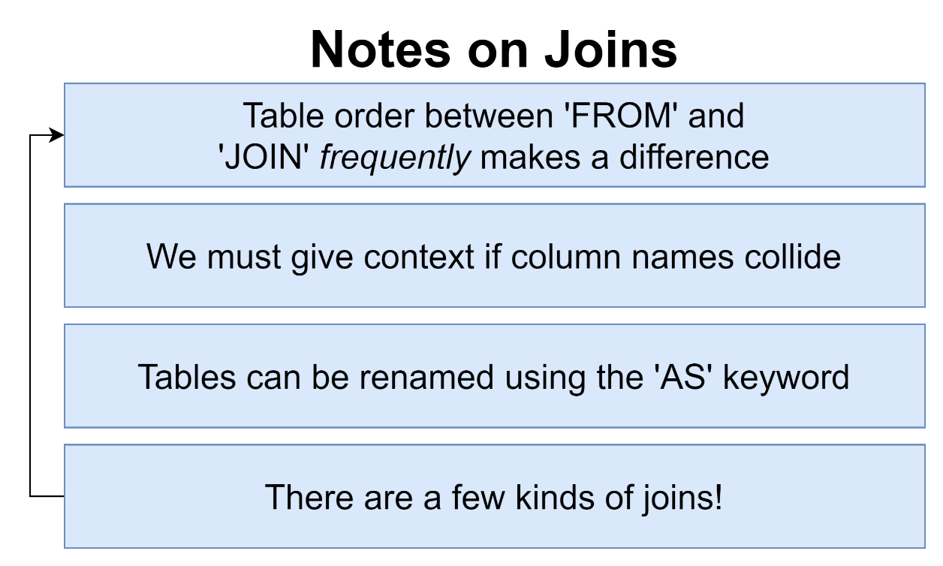 16

49. Alternate Forms of Syntax 16

50. Missing Data in Joins 17

51. Why Wasn't It Included 17

52. Four Kinds of Joins 17

53. Each Join in Practice 17

54. Does Order Matter? 17

Quiz 7: Test Your Joining Knowledge 17

55. Exercise Overview 17

Coding Exercise 10: Joins, Joins, Join! 17

56. Two Possible Solutions 17

57. Where with Join 17

58. Three Way Joins 17

59. A Bit of Practice 17

Coding Exercise 11: Three Way Exercise 18

60. Exercise Solution 18

76. A New Dataset 18

77. Investigating This Dataset 18

78. Some Group By Practice 18

Coding Exercise 15: Group By Review 19

79. Group By Review Solution 19

80. Remember Joins? 19

Coding Exercise 16: Inner Join Review 20

81. Of Course You Remember! 20

82. The Basics of Sorting 20

83. Two Variations on Sorting 20

84. Offset and Limit 20

85. Exercise Overview 20

Coding Exercise 17: Sorting, Offsetting, and Limiting 20

86. Exercise Solution 20

87. Handling Sets with Union 20

88. A Few Notes on Union 20

89. Commonalities with Intersect 21

90. Removing Commonalities with Except 21

91. Union Exercise Overview 21

Coding Exercise 18: Merging Results with Union 21

92. Exercise Solution 21

93. What's a Subquery? 22

94. Thinking About the Structure of Data 22

Quiz 9: What's the Data Look Like? 22

95. Subqueries in a Select 22

96. Exercise Overview 22

Coding Exercise 19: Embedding in Select 22

97. Select Solution 22

98. Subqueries in a From 23

99. From Subqueries that Return a Value 23

100. Example of a Subquery in a From 23

101. Exercise Overview 23

Coding Exercise 20: Subquery From's 23

102. Exercise Solution 23

103. Subqueries in a Join Clause 24

104. More Useful - Subqueries with Where 24

105. Data Structure with Where Subqueries 25

106. Exercise Overview 25

Coding Exercise 21: Subquery Where's 25

107. Exercise Solution 25

108. The Not In Operator with a List 25

109. A New Where Operator 25

110. Finally Some! 26

Quiz 10: Is It A Valid Subquery? 27

111. Exercise Overview 27

Coding Exercise 22: Practice Your Subqueries! 27

112. A Quick Solution 27

113. Probably Too Much About Correlated Subqueries 27

114. More on Correlated Subqueries 28

115. A Select Without a From? 29

116. Exercise Overview 29

Coding Exercise 23: From-less Selects 29

117. Exercise Solution 29

118. Selecting Distinct Values 29

119. Exercise Overview 29

Coding Exercise 24: Some Practice with Distinct 29

120. A Distinct Solution 29

121. The Greatest Value in a List 29

122. And the Least Value in a List! 30

123. The Case Keyword 30

124. PostgreSQL Installation on macOS 30

125. pgAdmin Setup on macOS 30

126. Postgres installation on Windows 30

127. What'd We Just Do? 30

128. Data Types 30

129. Fast Rules on Numeric Data Types 31

130. More on Number Data Types 31

131. Reminder on Character Types 32

132. Boolean Data Types 32

133. Times, Dates, and Timestamps 32

134. Really Awesome Intervals 34

135. Thinking About Validation 35

136. Creating and Viewing Tables in PGAdmin 35

137. Applying a Null Constraint 35

138. Solving a Gotcha with Null Constraints 35

Quiz 11: Creating NULL Constraints 35

139. Default Column Values 35

140. Applying a Unique Constraint to One column 35

141. Multi-Column Uniqueness 36

Quiz 12: Is It Unique? 36

142. Adding a Validation Check 36

143. Checks Over Multiple Columns 36

Quiz 13: Does It Pass a Check? 37

144. So Where Are We Applying Validation? 37

145. Approaching More Complicated Designs 37

146. Using a SQL Design Tool 37

147. A Config-based Schema Designer 38

148. Here's the Plan 38

149. Rebuilding Some Schema 38

150. Requirements of a Like System 38

151. How Not to Design a Like System 38

152. Designing a Like System 39

Quiz 14: Building a Similar System 39

153. Making a Reaction System Instead 39

154. Polymorphic Associations 40

155. Polymorphic Association Alternative Implementation 40

156. The Simplest Alternative 41

Quiz 15: Polymorphic Associations 41

157. So Which Approach? 41

158. Additional Features Around Posts 41

159. Adding Captions and Locations 42

160. Photo Mentions vs Caption Mentions 42

161. Considerations on Photo Tags vs Caption Tags 42

162. Update For Tags 42

163. Designing a Hashtag System 43

164. Tables for Hashtags 44

165. Including the Hashtag Table 44

166. A Few More User Columns 44

167. Why No Number of Followers or Posts? 44

168. Designing a Follower System 45

169. Back to Postgres 45

170. Creating Tables with Checks 45

171. Posts Creation 45

172. Comments Creation 45

173. Likes Creation 45

174. Photo Tags and Caption Tags 46

175. Creating Hashtags, Hashtag Posts, and Followers 46

176. Quick Note About Adding Some Data 46

177. Adding Some Data 46

178. Restoring from Scratch 46

179. Highest User ID's Exercise 46

180. Solution for User ID's 46

181. Posts by a Particular User 46

182. Solving for Posts by User 46

183. Likes Per User 46

184. Solution for Likes Per User 46

185. Thinking About Performance 47

186. Where Does Postgres Store Data? 47

187. Heaps, Blocks, and Tuples 47

Quiz 16: Terminology Check 48

188. Block Data Layout 49

189. Heap File Layout 49

190. Full Table Scans 50

191. What's an Index 50

192. How an Index Works 50

193. Creating an Index 52

194. Benchmarking Queries 53

195. Downsides of Indexes 53

196. Index Types 54

197. Automatically Generated Indexes 54

Quiz 17: Using Automatically Created Indexes 55

198. Behind the Scenes of Indexes 55

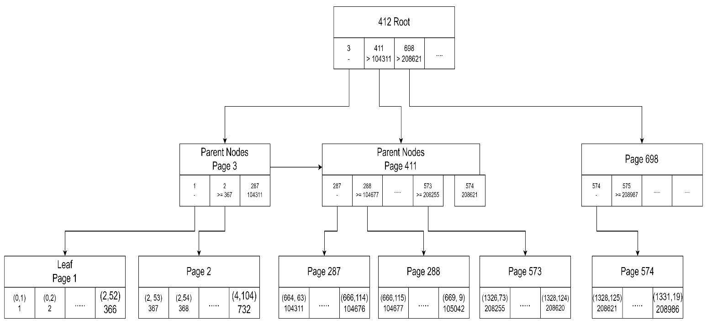 57

199. The Query Processing Pipeline 57

200. Explain and Explain Analyze 59

Quiz 18: Explain Vs Explain Analyze 59

201. Solving an Explain Mystery 59

202. Developing an Intuitive Understanding of Cost 61

203. Calculating Cost by Hand 61

204. A Touch More on Costs 61

Quiz 19: Calculating Costs 61

205. up vs Total Costs 61

206. Costs Flow Up 61

207. Use My Index! 61

208. Common Table Expressions 62

209. A Quick Solution 62

210. So What's a CTE? 62

211. Recursive CTE's 62

212. Recursive CTE's Step by Step 62

213. Why Use Recursive CTE's? 62

214. Writing the Query 62

215. Walking Through Recursion 62

216. Most Popular Users 62

217. A Possible Solution for Merging Tables 62

218. Creating a View 62

219. When to Use a View? 63

220. Deleting and Changing Views 63

221. Materialized Views 63

222. Grouping by Week 63

223. Reminder on Left Joins 63

224. Writing a Slow Query 63

225. Creating and Refreshing Materialized Views 63

Quiz 20: Views vs Materialized Views 63

226. What are Transactions Used For? 63

227. Some Sample Data 63

228. Opening and Closing Transactions 63

229. Transaction Cleanup on Crash 63

230. Closing Aborted Transactions 64

231. A Story on Migrations 64

232. Migration Files 64

233. Issues Solved by Migrations 64

234. A Few Notes on Migrations Libraries 64

235. A Note About Node Installation 64

236. Project Creation 64

237. Generating and Writing Migrations 64

238. Applying and Reverting Migrations 64

239. Generating and Applying a Second Migration 64

240. Schema vs Data Migrations 64

241. Dangers Around Data Migrations 65

242. Properly Running Data and Schema Migrations 65

243. Creating a Posts Table 65

244. A Small Web Server 65

245. Web Server Setup Instructions 65

246. Adding the Loc Column 65

247. Writing Values to Both Columns 65

248. Transaction Locks 65

249. Updating Values 65

250. Migrations Setup Instructions 65

251. Updating the App Server 65

252. Dropping the Last Columns 66

253. Section Goal 66

254. Initial Setup 66

255. One Fast Migration 66

256. Building the Users Router 66

257. Understanding Connection Pools 66

258. Validating Connection Credentials 66

259. Query and Close 66

260. The Repository Pattern 66

261. Creating a Repository 66

262. Accessing the API 66

263. Casing Issues 67

264. Fixing Casing 67

265. Finding Particular Users 67

266. SQL Injection Exploits 67

267. Handling SQL Injection with Prepared Statements 67

268. Preventing SQL Injection 67

269. Reminder on Post Requests 67

270. Inserting Users 67

271. Handling Updates 67

272. And, Finally, Delete 67

273. A Note on Testing 67

274. Assertions Around User Count 68

275. Connecting to a DB For Tests 68

276. Disconnecting After Tests 68

277. Multi-DB Setup 68

278. Assumptions Around Content 68

279. Issues with Parallel Tests 68

280. Isolation with Schemas 68

281. Creating and Accessing Schemas 68

282. Controlling Schema Access with Search Paths 68

283. Routing Schema Access 68

284. Strategy for Isolation 68

285. Programmatic Schema Creation 69

286. Escaping Identifiers 69

287. Test Helpers 69

288. Cleaning up Schemas and Roles 69

289. Finally... Parallel Tests! (Final Lecture) 69

290. Bonus! 69

# Simple but Powerful SQL Statements

## 3. What is PostgreSQL All About?

## 4. Database Design

Quiz 1: Database Terminology

## 5. Creating Tables

## 6. Analyzing CREATE TABLE

## 7. Inserting Data Into a Table

## 8. Retrieving Data with Select

Coding Exercise 1: Create, Insert, and Select!

## 9. Calculated Columns

## 10. Calculating Phone Revenue

## Coding Exercise 2: Using Calculated Columns

## 11. Exercise Solution

## 12. String Operators and Functions

## 13. Filtering Rows with "Where"

## 14. More on the "Where" Keyword

## 15. Compound "Where" Clauses

## 16. A "Where" Exercise Overview

## Coding Exercise 3: Practicing Where Statements

## 17. A "Where" Solution

## 18. "Where" With Lists

## Coding Exercise 4: A More Challenging 'Where'

## 19. A "Where" With Lists Solution

## 20. Calculations in "Where" Clauses

## Coding Exercise 5: Trying Calculations in Where Clauses

## 21. Solving Calculations

## 22. Updating Rows

## 23. Deleting Rows

## Coding Exercise 6: Try Updating Records In a Table!

## 24. A Solution for Updating Rows

## Coding Exercise 7: Practice Deleting Records

## 25. Solution for Deleting Rows

## 26. The Plan Moving Forward

## 27. Approaching Database Design

## Quiz 2: Let's Design Some Schema

## 28. One-to-Many and Many-to-One Relationships

## Quiz 3: A 'Has One' or 'Has Many'?

## 29. One-to-One and Many-to-Many Relationships

## Quiz 4: Identifying One-to-One and Many-to-Many Relationships

## 30. Primary Keys and Foreign Keys

## 31. Understanding Foreign Keys

Quiz 5: Foreign Keys; How Do They Work?

## 32. Auto-Generated ID's

## 33. Creating Foreign Key Columns

## 34. Running Queries on Associated Data

## 35. Exercise Overview

## Coding Exercise 8: Creating and Using Foreign Keys

## 36. Foreign Key Creation Solution

## 37. Foreign Key Constraints Around Insertion

## 38. Constraints Around Deletion

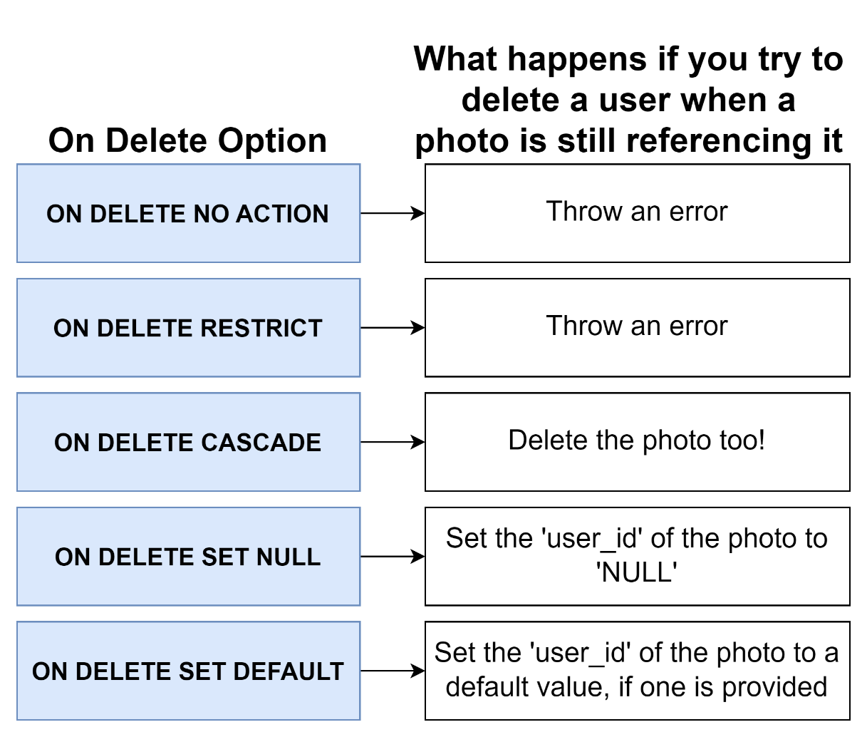

## 39. Commands You’ll Need for the Next Video

## 40. Testing Deletion Constraints

## 41. Setting Foreign Keys to Null on Delete

## Quiz 6: What Happens On Delete?

## 42. Adding Some Complexity

## 43. Adding Some Data

## 44. Queries with Joins and Aggregations

## 45. Joining Data from Different Tables

## 46. Another Quick Join

## 47. Exercise Overview

## Coding Exercise 9: Practice Joining Data

## 48. A Joinful Solution

## 

## 49. Alternate Forms of Syntax

## 50. Missing Data in Joins

## 51. Why Wasn't It Included

## 52. Four Kinds of Joins

## 53. Each Join in Practice

## 54. Does Order Matter?

## Quiz 7: Test Your Joining Knowledge

## 55. Exercise Overview

## Coding Exercise 10: Joins, Joins, Join!

## 56. Two Possible Solutions

## 57. Where with Join

## 58. Three Way Joins

## 59. A Bit of Practice

## Coding Exercise 11: Three Way Exercise

## 60. Exercise Solution

## 76. A New Dataset

## 77. Investigating This Dataset

## 78. Some Group By Practice

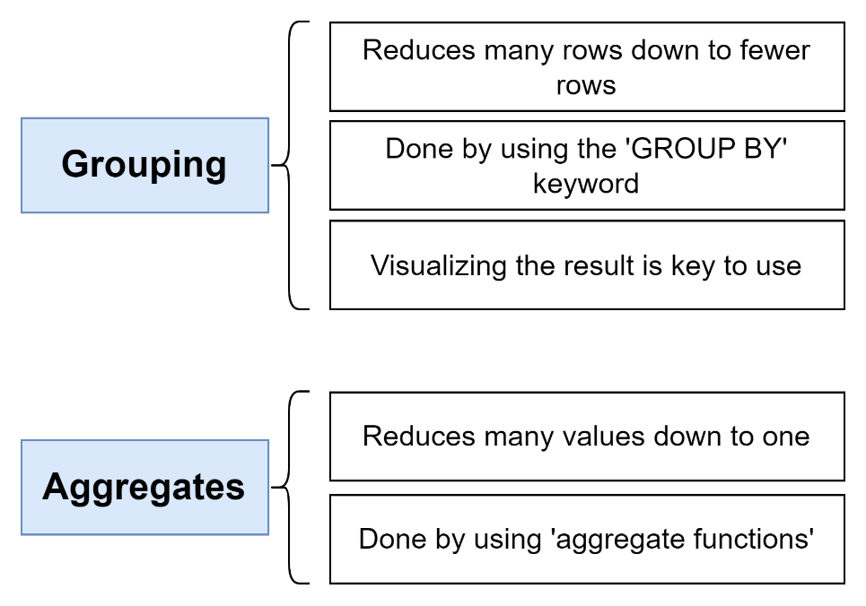

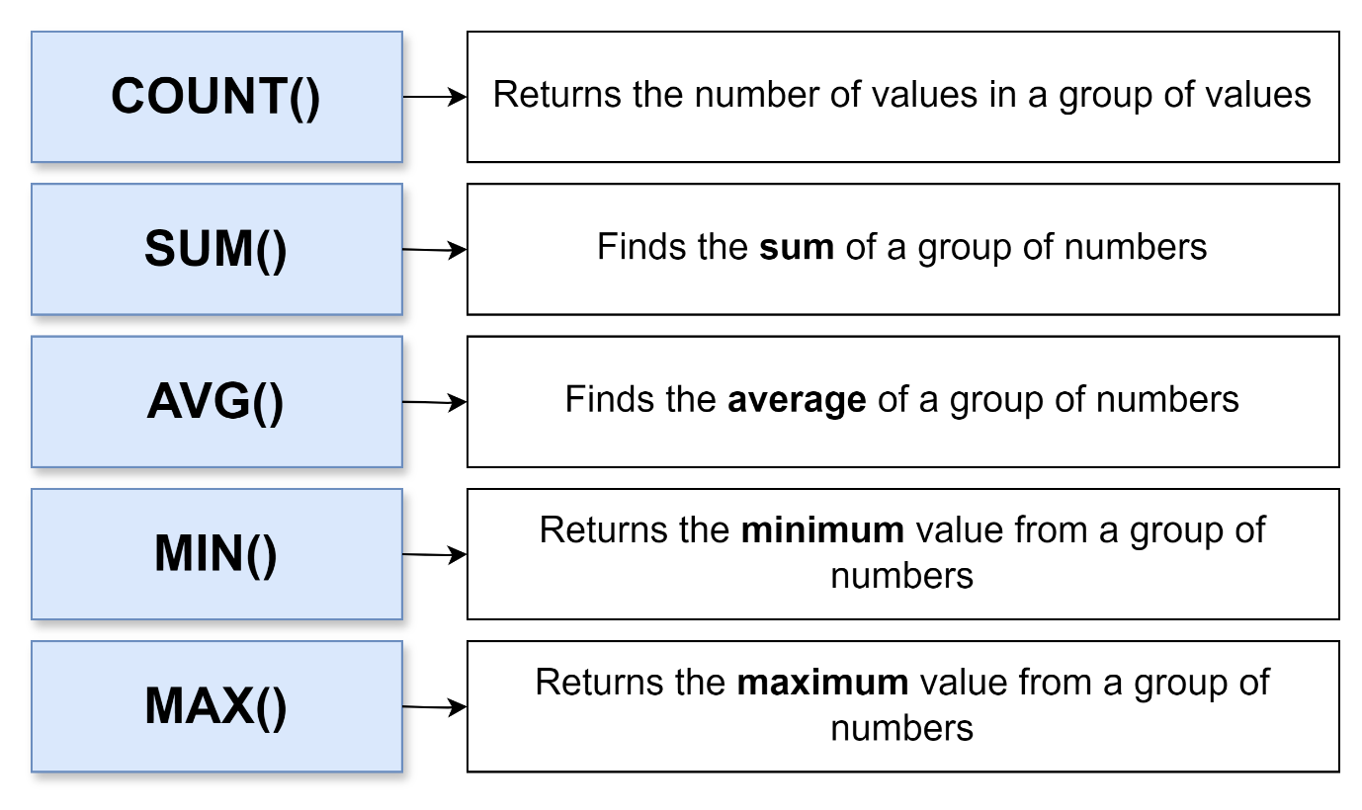

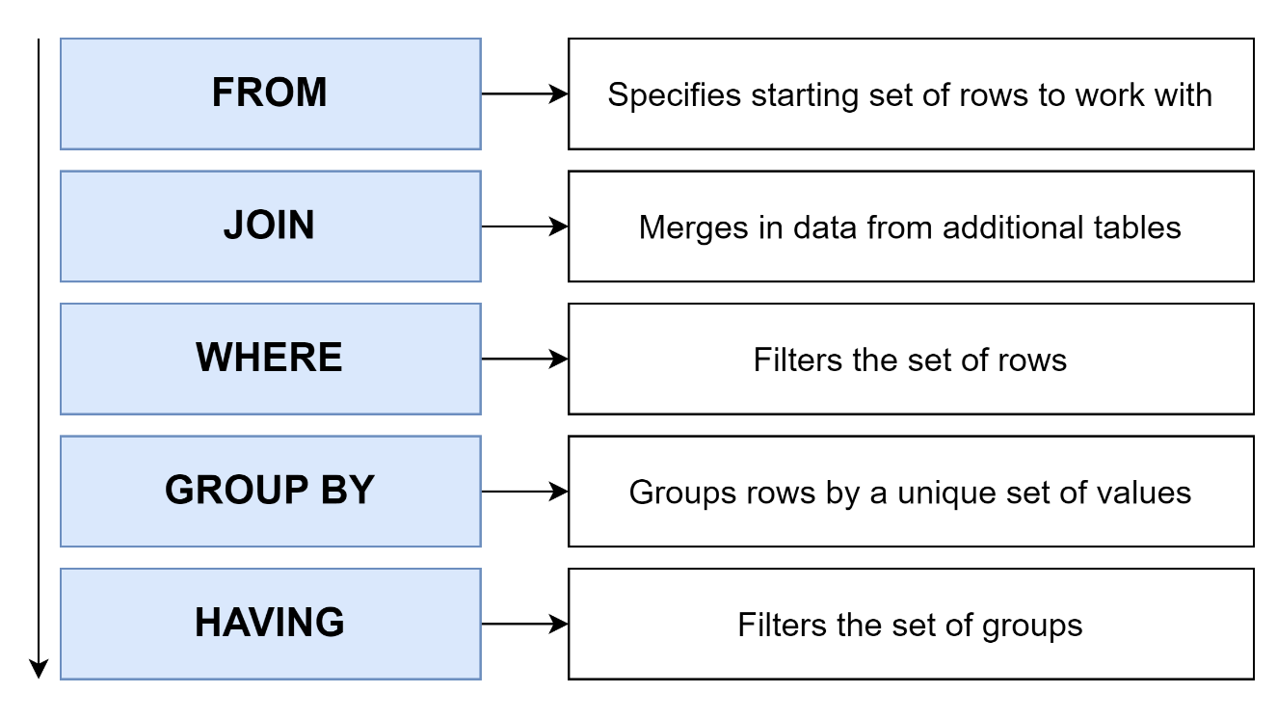

## Coding Exercise 15: Group By Review

## 79. Group By Review Solution

## 80. Remember Joins?

## Coding Exercise 16: Inner Join Review

## 81. Of Course You Remember!

## 82. The Basics of Sorting

## 83. Two Variations on Sorting

## 84. Offset and Limit

## 85. Exercise Overview

## Coding Exercise 17: Sorting, Offsetting, and Limiting

## 86. Exercise Solution

## 87. Handling Sets with Union

## 88. A Few Notes on Union

UNION 🡪 Join together results of 2 queries and remove duplicate rows

UNION ALL 🡪

INTERSECT 🡪 Find rows in common in the results of 2 queries and remove duplicate rows

INTERSECT ALL 🡪

EXCEPT 🡪 Find rows that are present in first query but not second query and remove duplicate rows

EXCEPT ALL 🡪

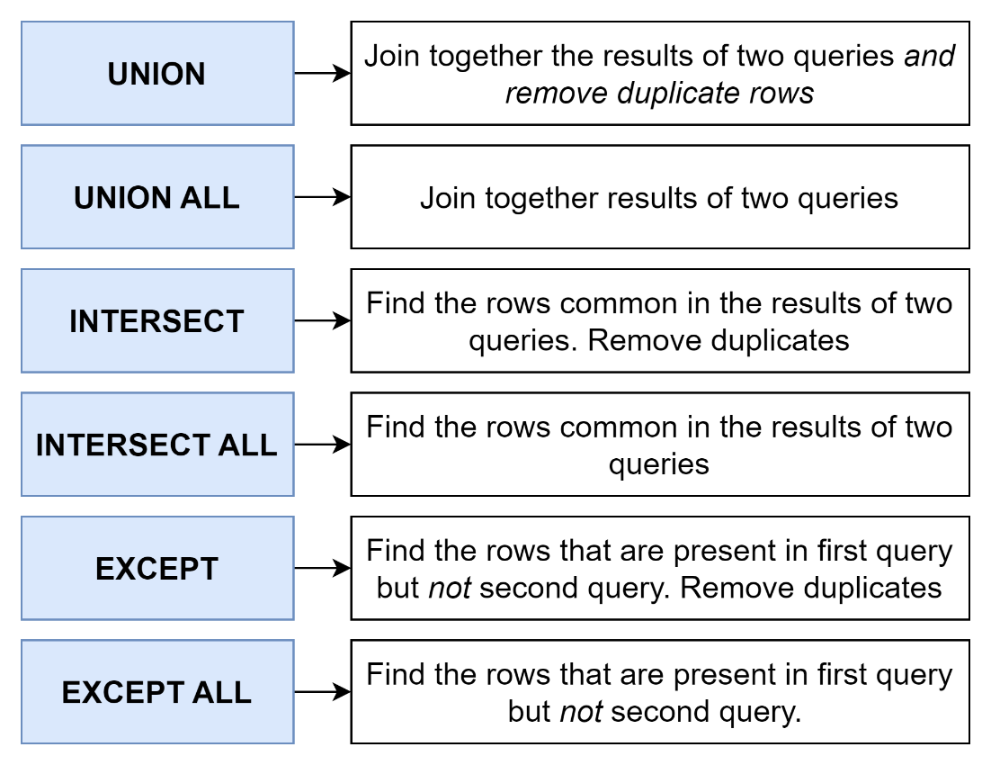

## 89. Commonalities with Intersect

## 90. Removing Commonalities with Except

## 91. Union Exercise Overview

## Coding Exercise 18: Merging Results with Union

## 92. Exercise Solution

## 93. What's a Subquery?

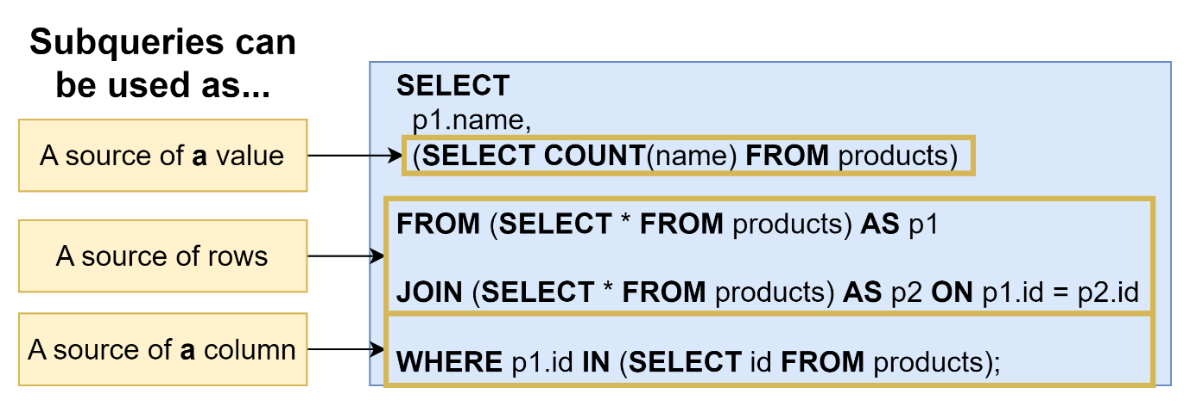

## 94. Thinking About the Structure of Data

## Quiz 9: What's the Data Look Like?

## 95. Subqueries in a Select

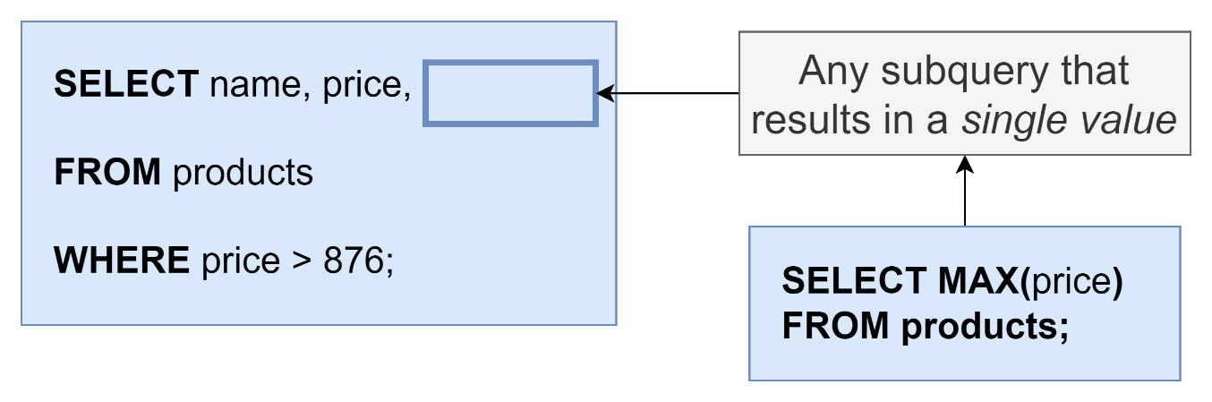

## 96. Exercise Overview

## Coding Exercise 19: Embedding in Select

## 97. Select Solution

## 98. Subqueries in a From

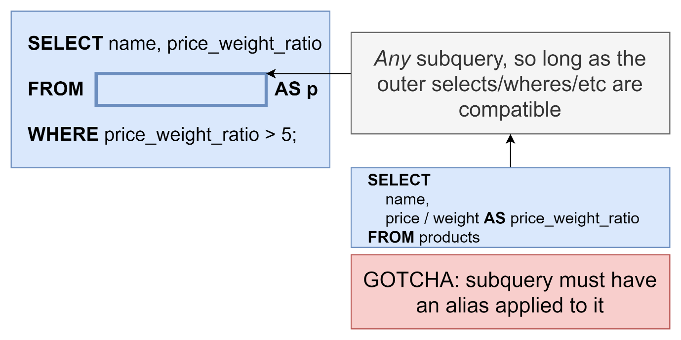

## 99. From Subqueries that Return a Value

## 100. Example of a Subquery in a From

## 101. Exercise Overview

## Coding Exercise 20: Subquery From's

## 102. Exercise Solution

## 103. Subqueries in a Join Clause

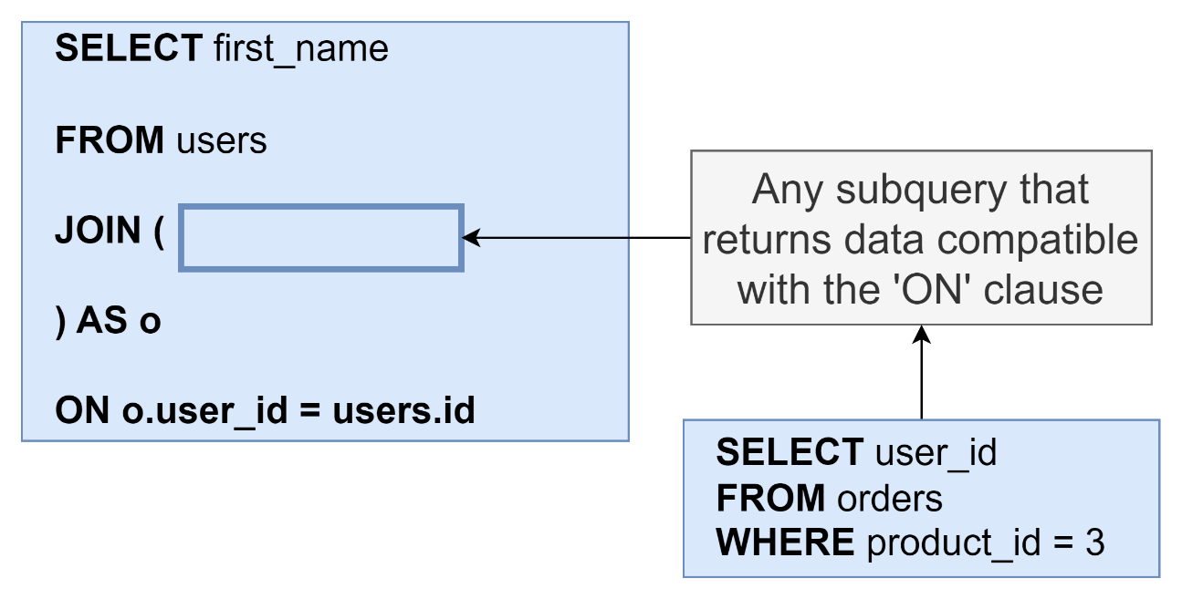

## 104. More Useful - Subqueries with Where

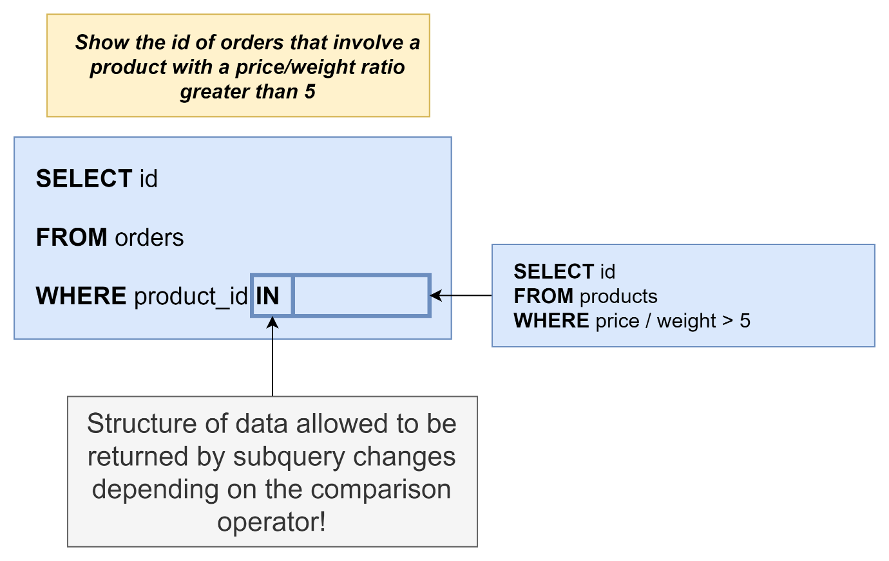

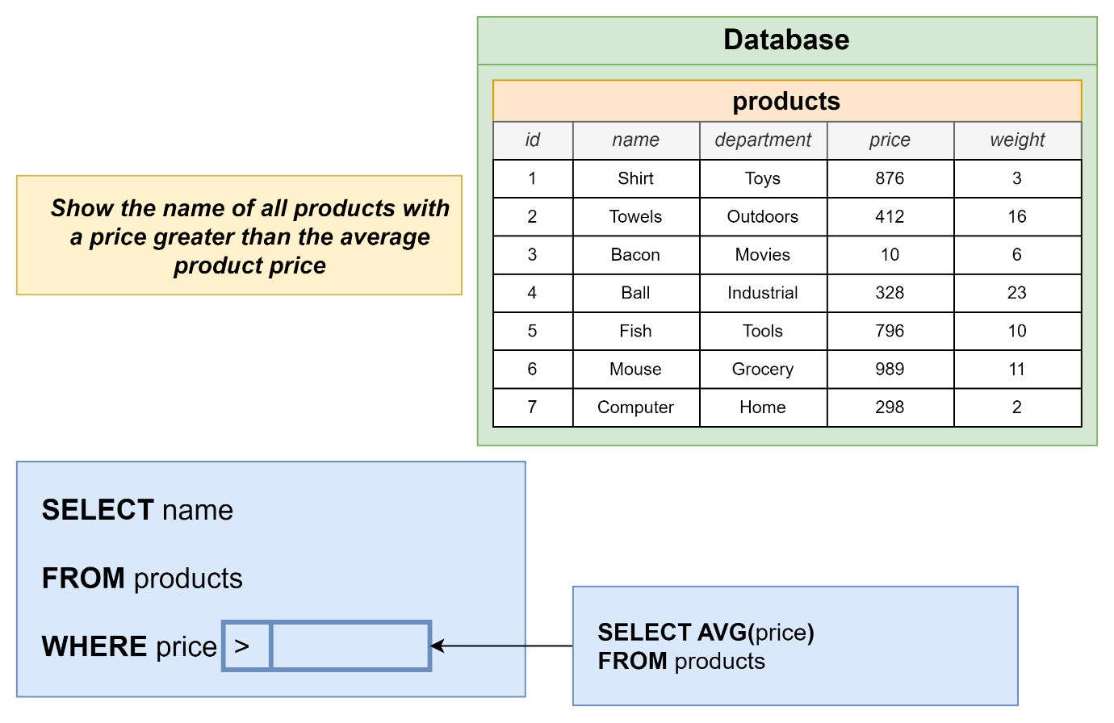

## 105. Data Structure with Where Subqueries

## 106. Exercise Overview

## Coding Exercise 21: Subquery Where's

## 107. Exercise Solution

## 108. The Not In Operator with a List

## 109. A New Where Operator

## 110. Finally Some!

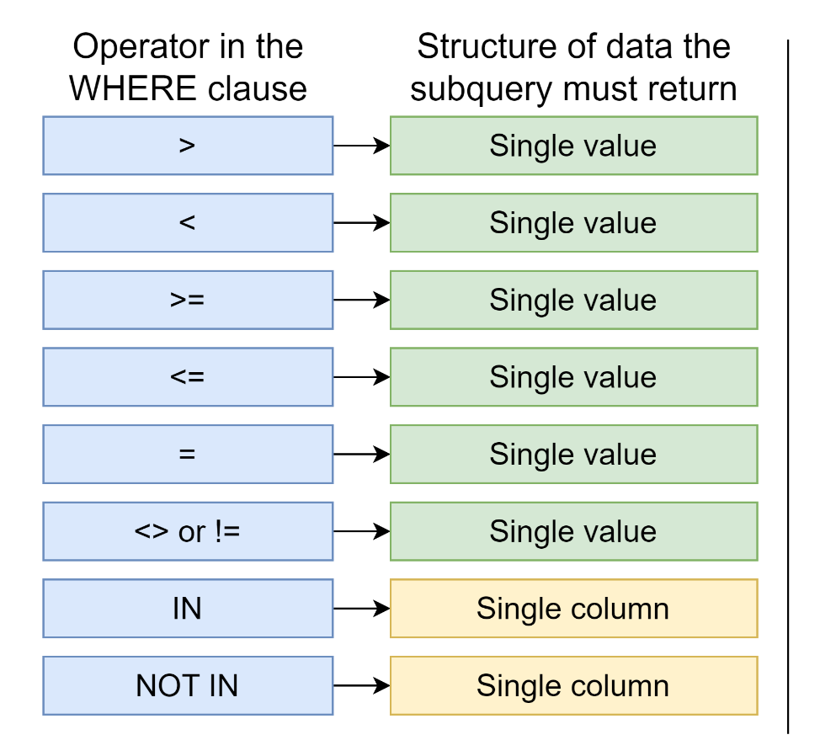

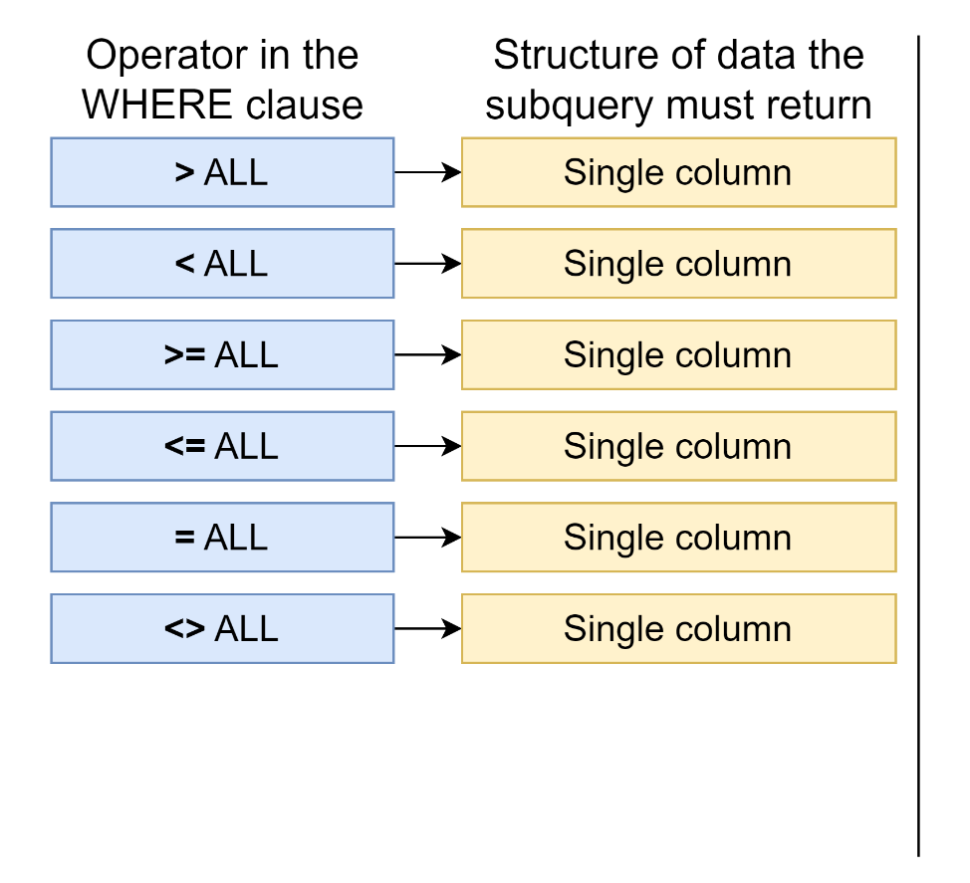

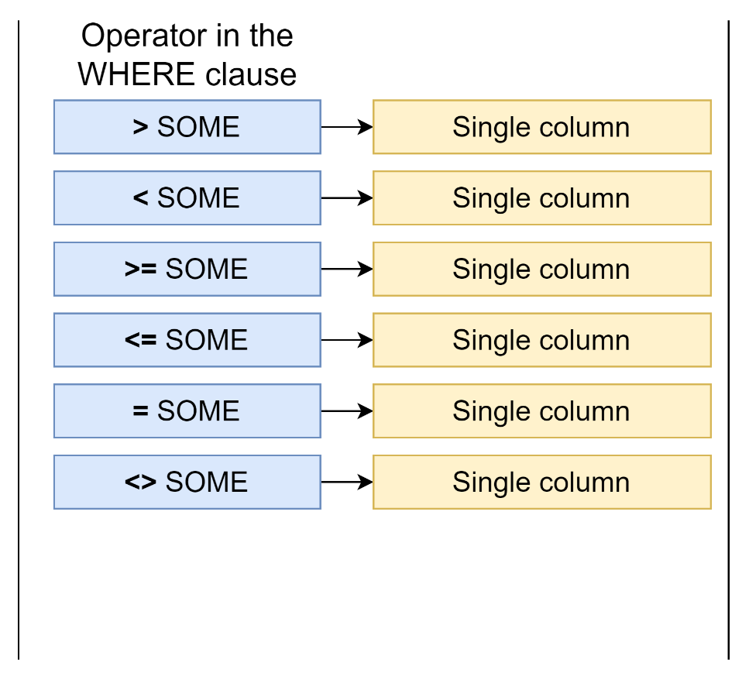

## Quiz 10: Is It A Valid Subquery?

## 111. Exercise Overview

## Coding Exercise 22: Practice Your Subqueries!

## 112. A Quick Solution

## 113. Probably Too Much About Correlated Subqueries

## 114. More on Correlated Subqueries

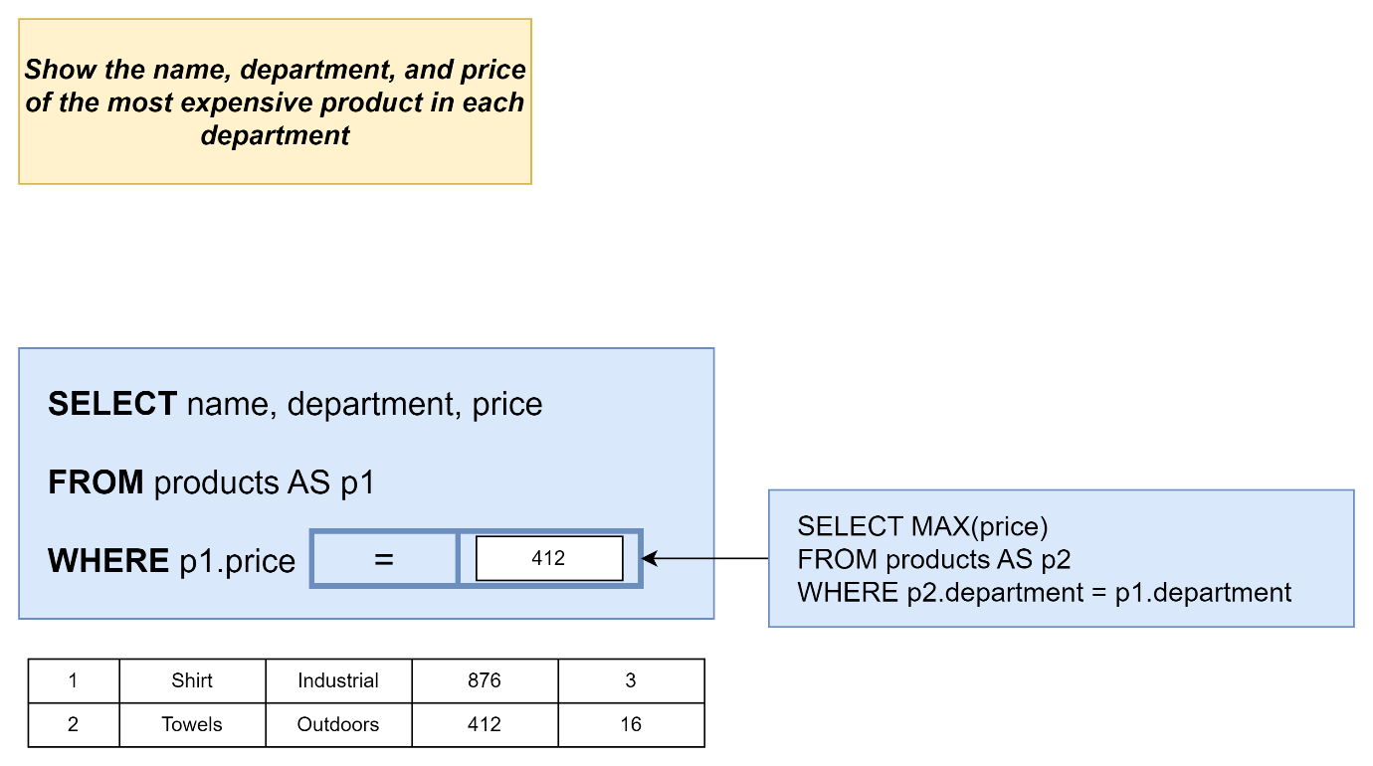

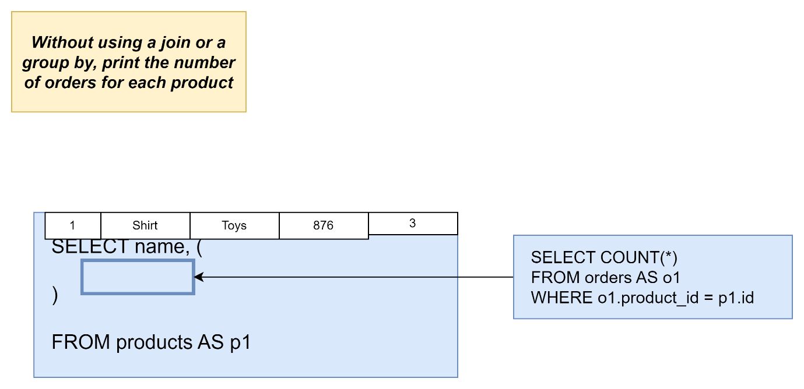

## 115. A Select Without a From?

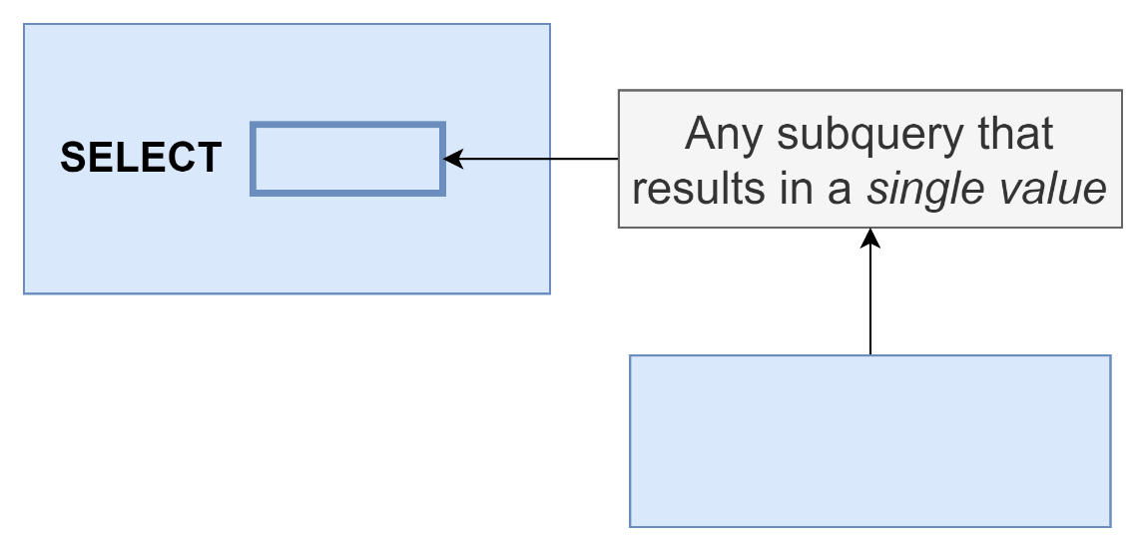

## 116. Exercise Overview

## Coding Exercise 23: From-less Selects

## 117. Exercise Solution

## 118. Selecting Distinct Values

## 119. Exercise Overview

## Coding Exercise 24: Some Practice with Distinct

## 120. A Distinct Solution

## 121. The Greatest Value in a List

Select name,weight , greatest(30,2*weight)

From products;

## 122. And the Least Value in a List!

## 123. The Case Keyword

Select name,price

CASE

When price > 500 then ‘high’

When price < 300 then ‘medium’

Else ‘cheap’

END

From products;

## 124. PostgreSQL Installation on macOS

## 125. pgAdmin Setup on macOS

## 126. Postgres installation on Windows

## 127. What'd We Just Do?

## 128. Data Types

## 129. Fast Rules on Numeric Data Types

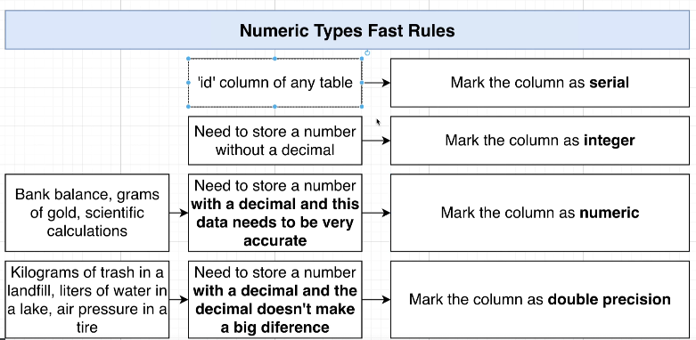

## 130. More on Number Data Types

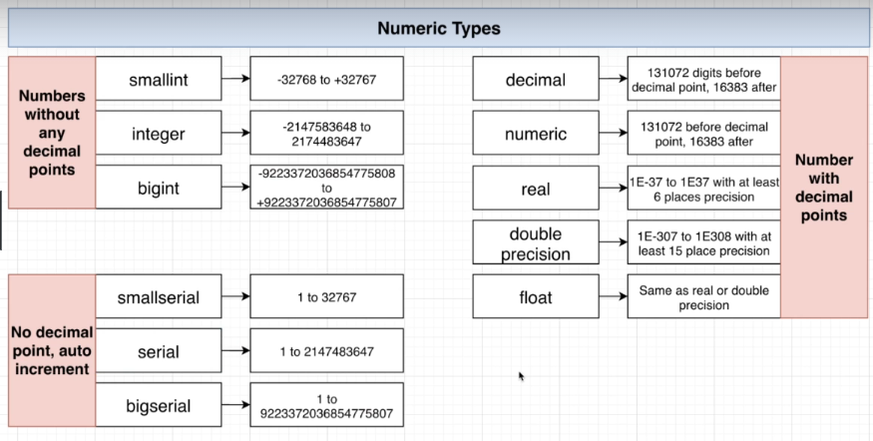

## 131. Reminder on Character Types

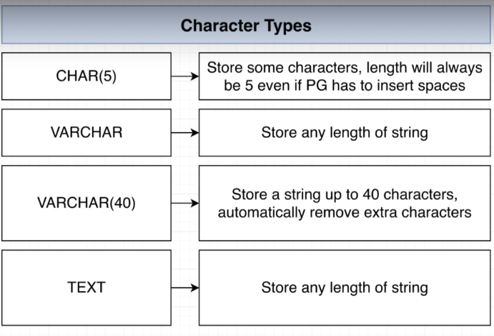

No performance difference

## 132. Boolean Data Types

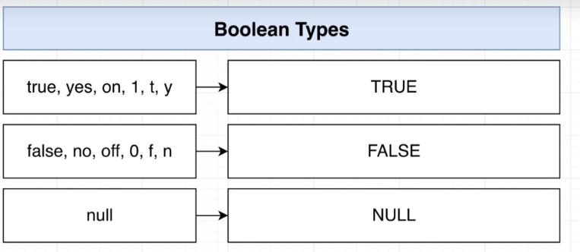

Null isnot true nor false

## 133. Times, Dates, and Timestamps

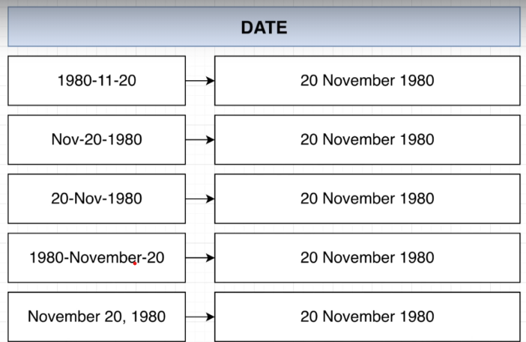

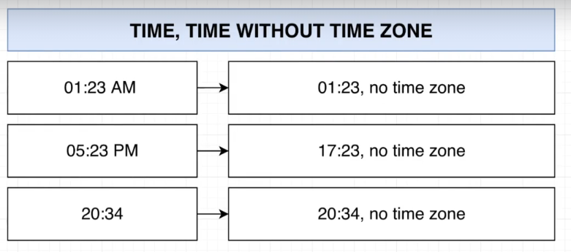

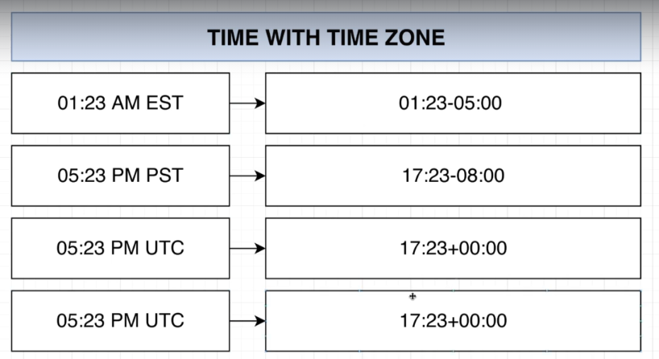

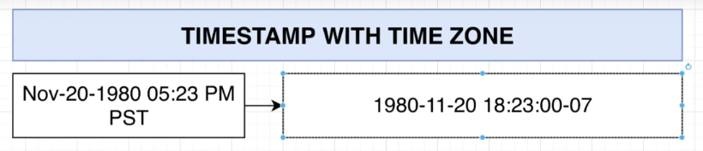

## 134. Really Awesome Intervals

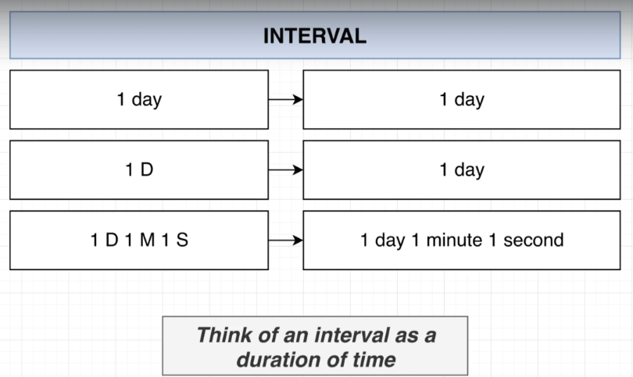

## 135. Thinking About Validation

## 136. Creating and Viewing Tables in PGAdmin

## 137. Applying a Null Constraint

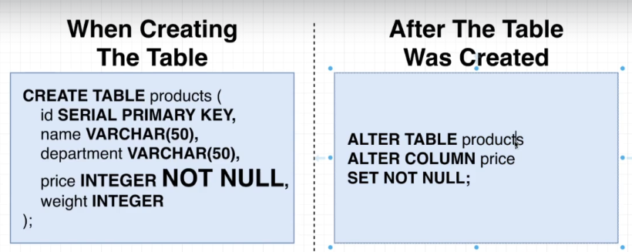

## 138. Solving a Gotcha with Null Constraints

## Quiz 11: Creating NULL Constraints

## 139. Default Column Values

## 140. Applying a Unique Constraint to One column

## 141. Multi-Column Uniqueness

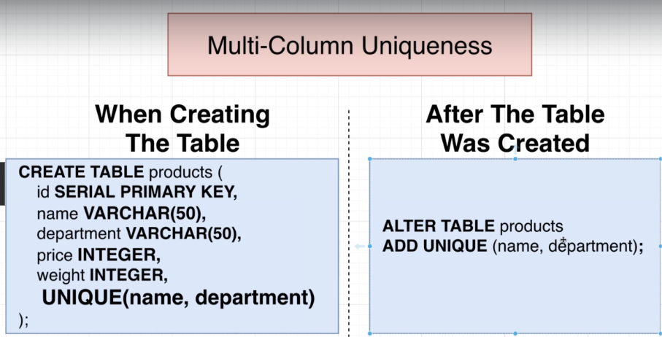

## Quiz 12: Is It Unique?

## 142. Adding a Validation Check

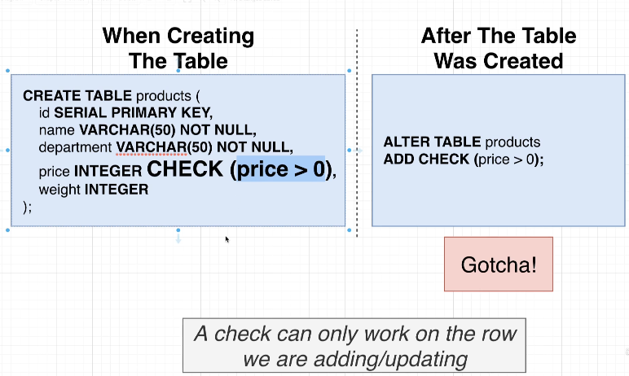

## 143. Checks Over Multiple Columns

## Quiz 13: Does It Pass a Check?

## 144. So Where Are We Applying Validation?

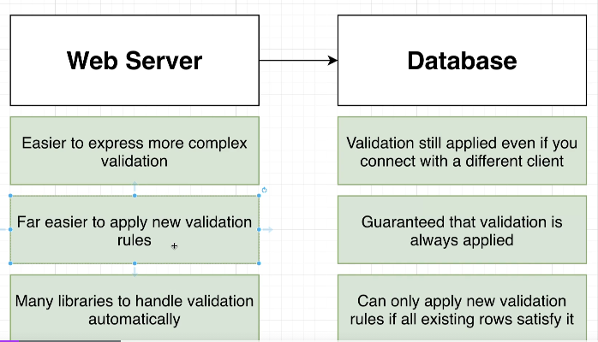

## 145. Approaching More Complicated Designs

## 146. Using a SQL Design Tool

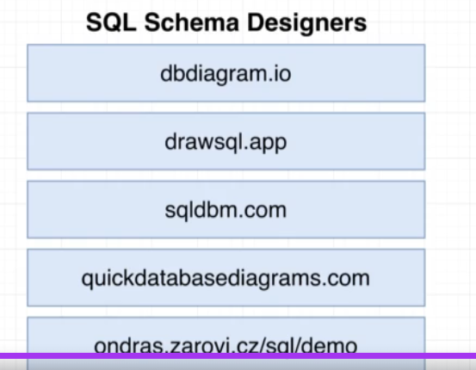

## 147. A Config-based Schema Designer

## 148. Here's the Plan

## 149. Rebuilding Some Schema

## 150. Requirements of a Like System

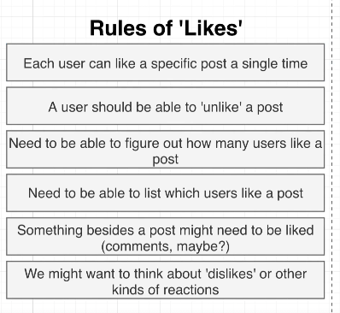

## 151. How Not to Design a Like System

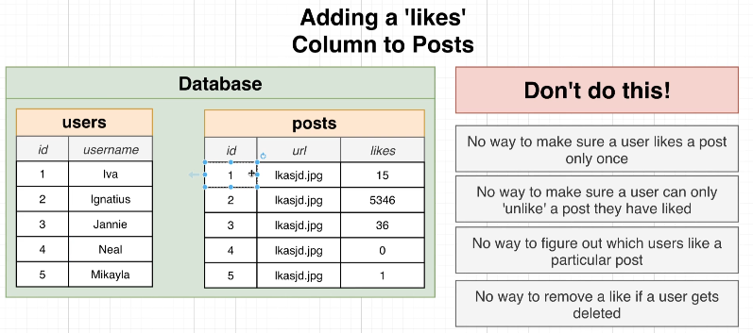

## 152. Designing a Like System

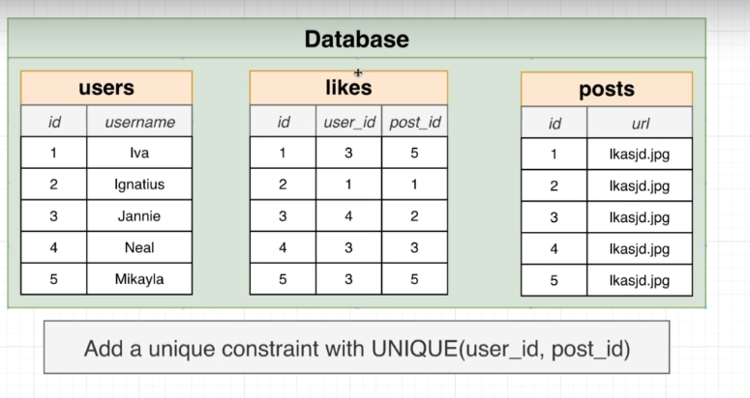

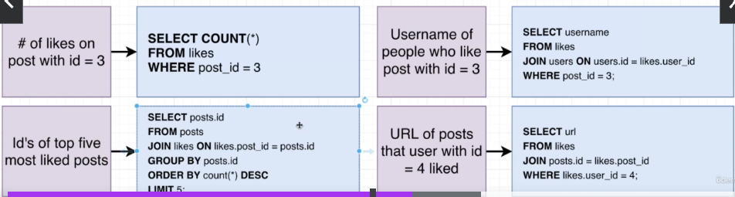

## Quiz 14: Building a Similar System

## 153. Making a Reaction System Instead

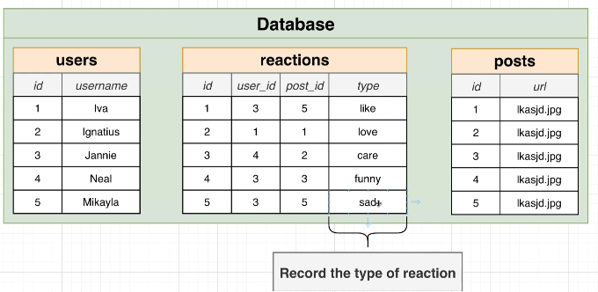

## 154. Polymorphic Associations

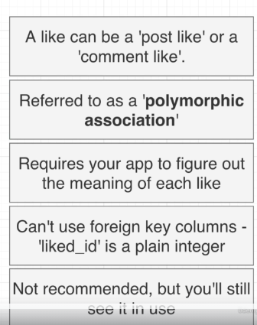

Like_type 🡪 post or comment

## 155. Polymorphic Association Alternative Implementation

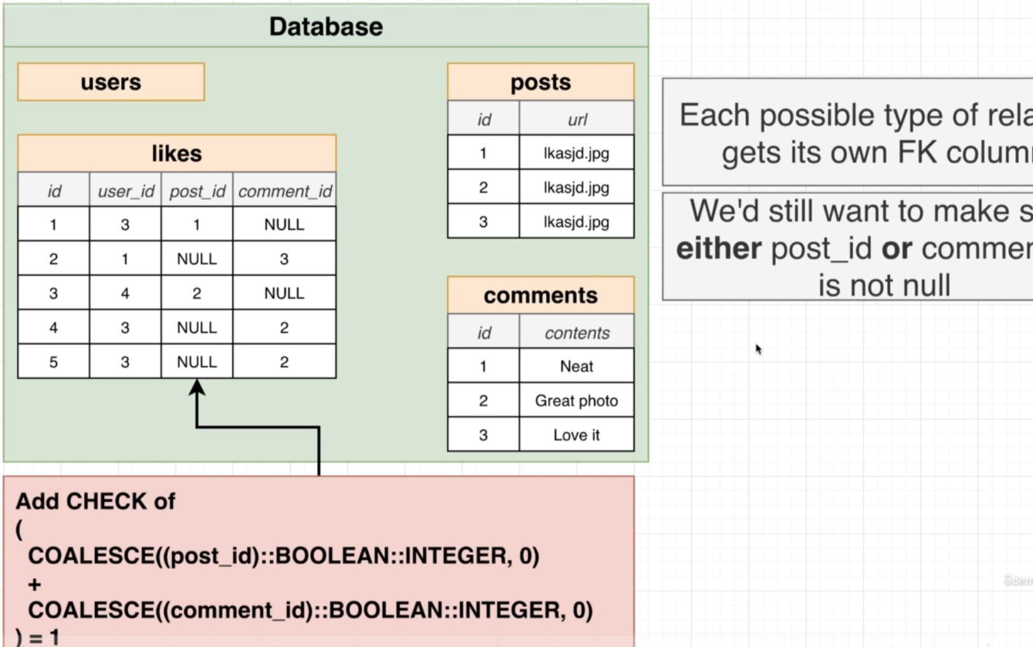

COALESCE gives first non null value

COALESCE(null,5) 🡪 5

## 156. The Simplest Alternative

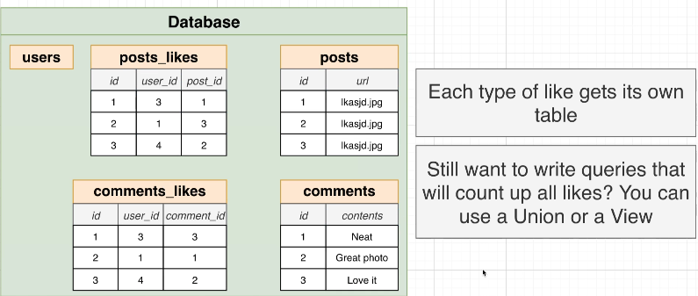

## Quiz 15: Polymorphic Associations

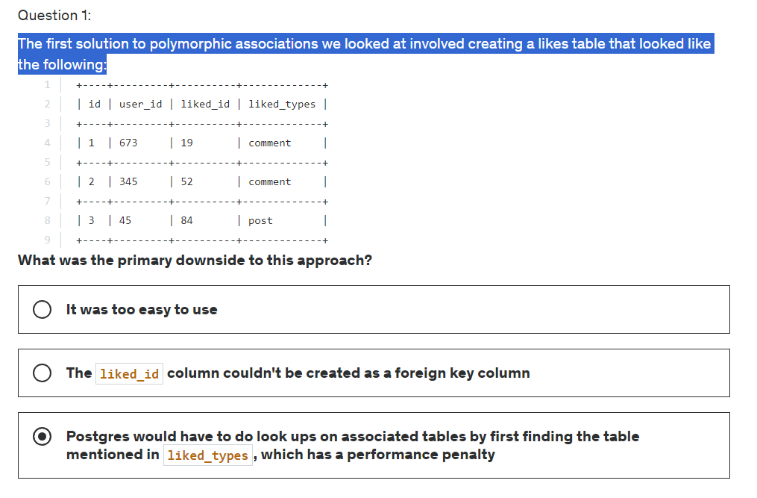

Option2 is correct

## 157. So Which Approach?

## 158. Additional Features Around Posts

## 159. Adding Captions and Locations

## 160. Photo Mentions vs Caption Mentions

## 161. Considerations on Photo Tags vs Caption Tags

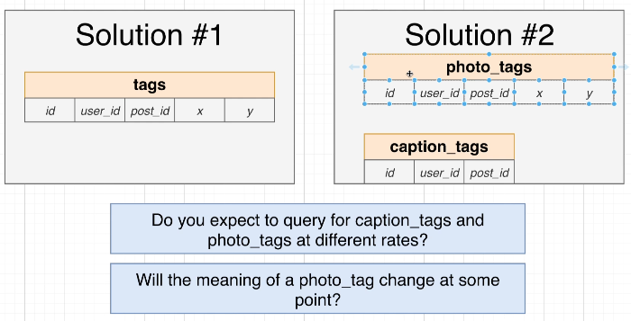

## 162. Update For Tags

## 163. Designing a Hashtag System

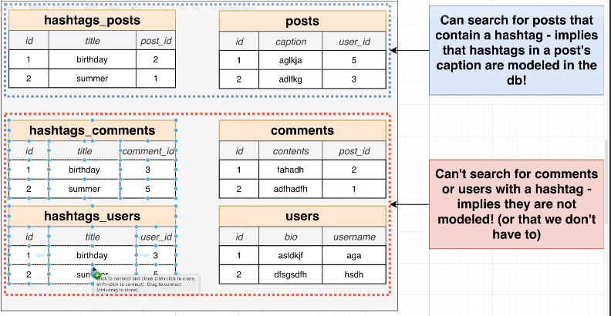

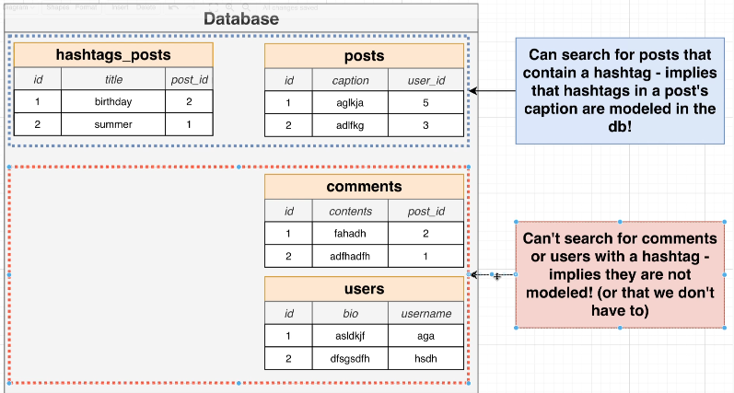

## 164. Tables for Hashtags

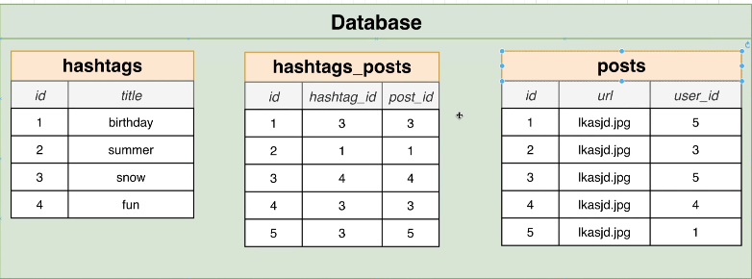

## 165. Including the Hashtag Table

## 166. A Few More User Columns

## 167. Why No Number of Followers or Posts?

## 168. Designing a Follower System

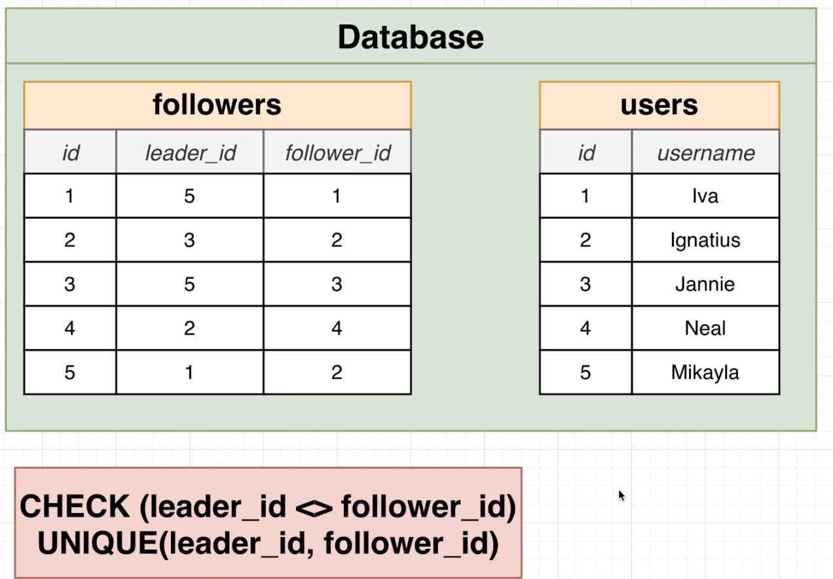

## 169. Back to Postgres

## 170. Creating Tables with Checks

## 171. Posts Creation

## 172. Comments Creation

## 173. Likes Creation

## 174. Photo Tags and Caption Tags

## 175. Creating Hashtags, Hashtag Posts, and Followers

## 176. Quick Note About Adding Some Data

## 177. Adding Some Data

## 178. Restoring from Scratch

## 179. Highest User ID's Exercise

## 180. Solution for User ID's

## 181. Posts by a Particular User

## 182. Solving for Posts by User

## 183. Likes Per User

## 184. Solution for Likes Per User

## 185. Thinking About Performance

## 186. Where Does Postgres Store Data?

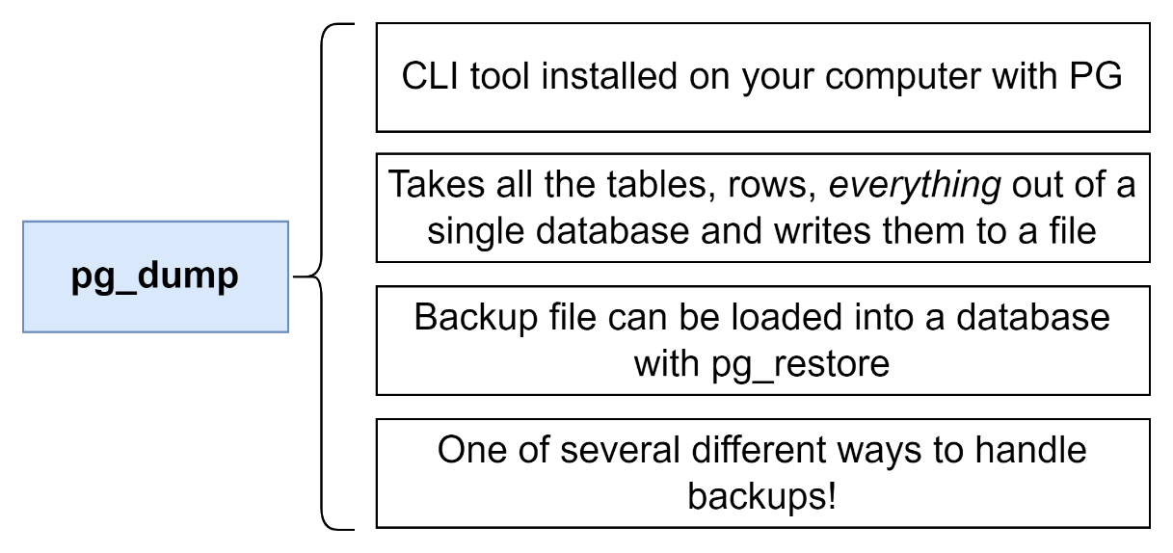

Show data_directory;

Base 🡪

Select oid, datname

From pg_database;

Select * from pg_class;

## 187. Heaps, Blocks, and Tuples

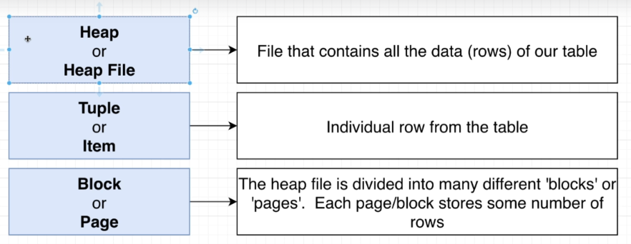

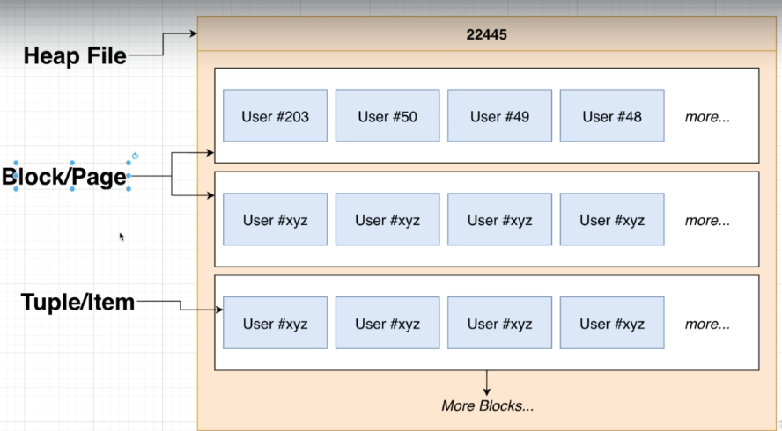

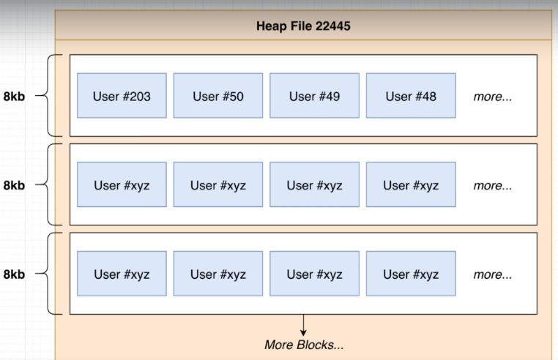

## Quiz 16: Terminology Check

## 188. Block Data Layout

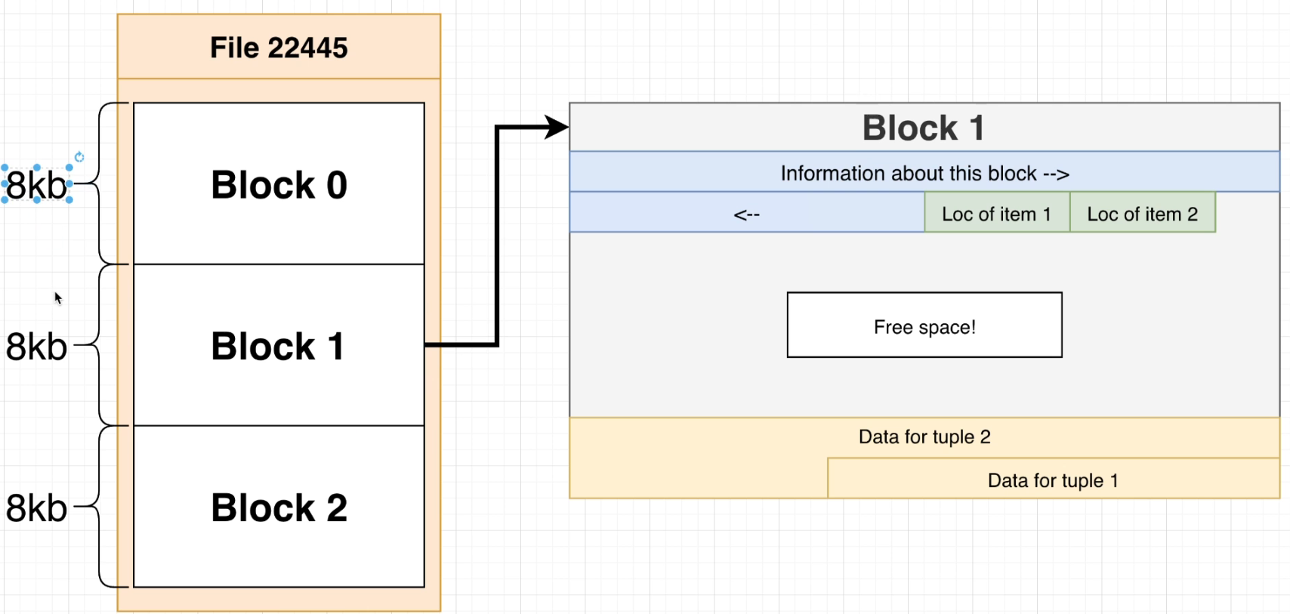

## 189. Heap File Layout

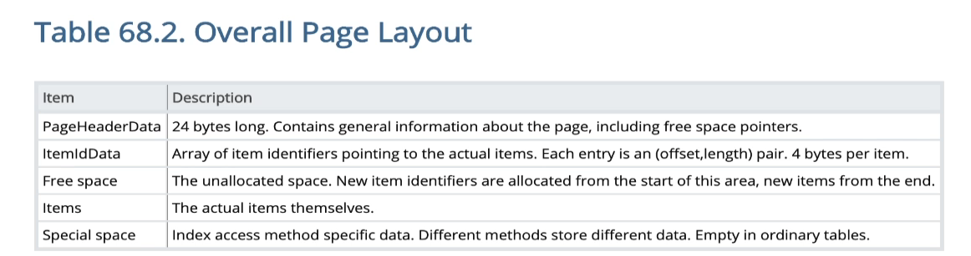

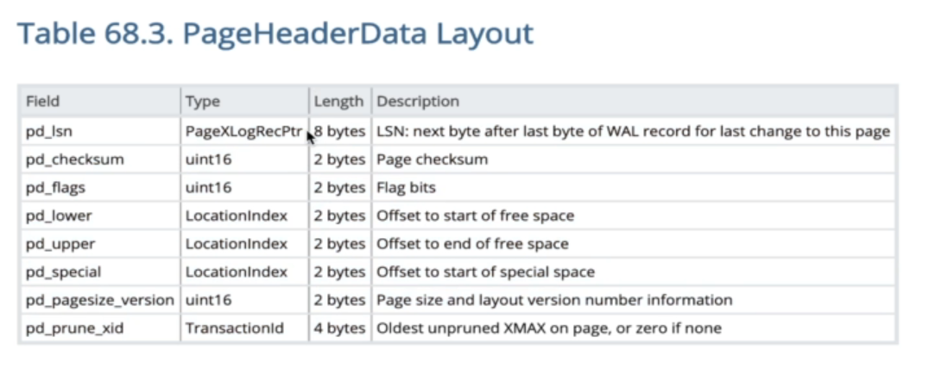

## 190. Full Table Scans

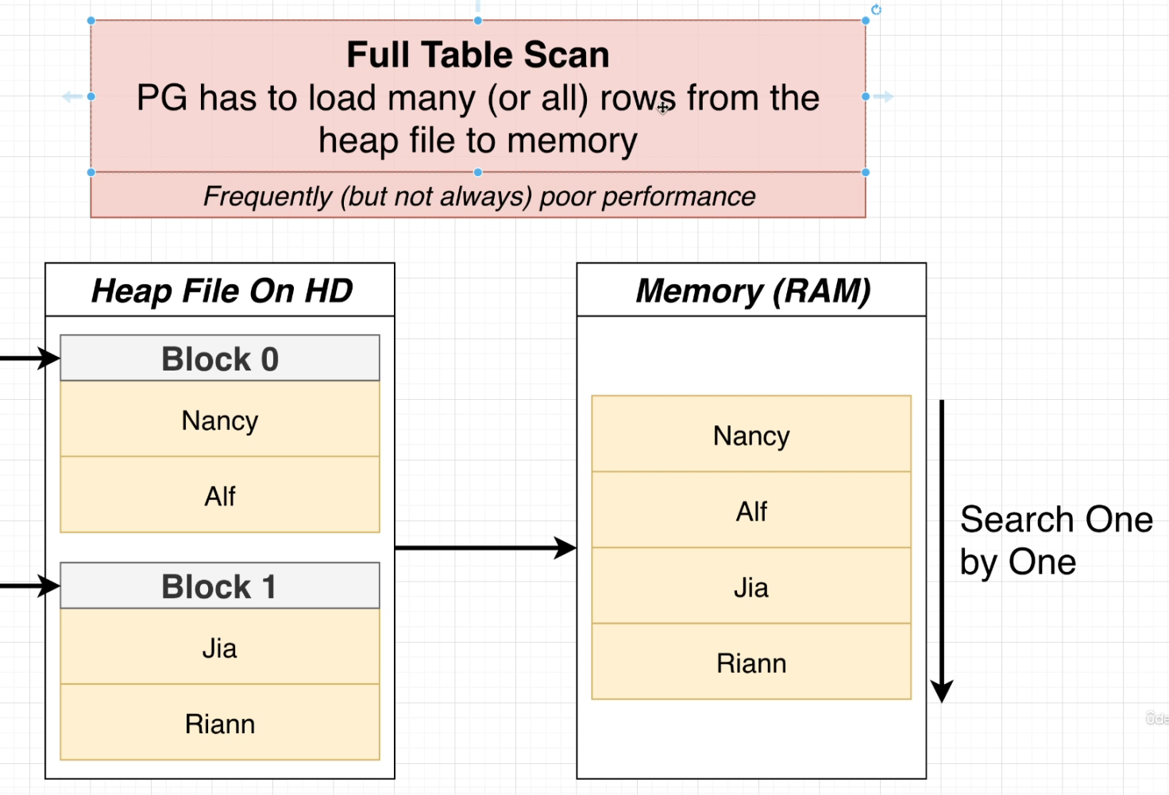

## 191. What's an Index

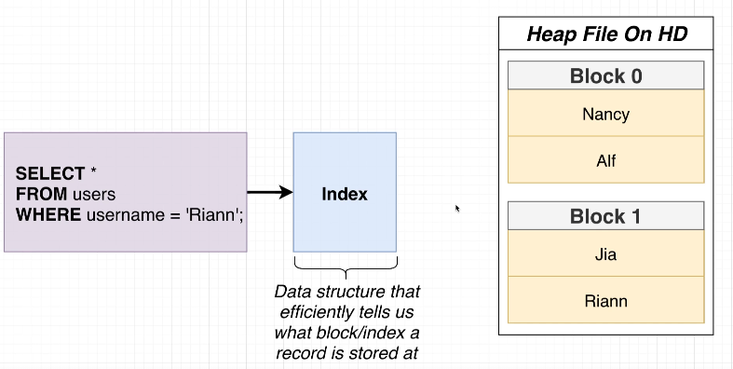

## 192. How an Index Works

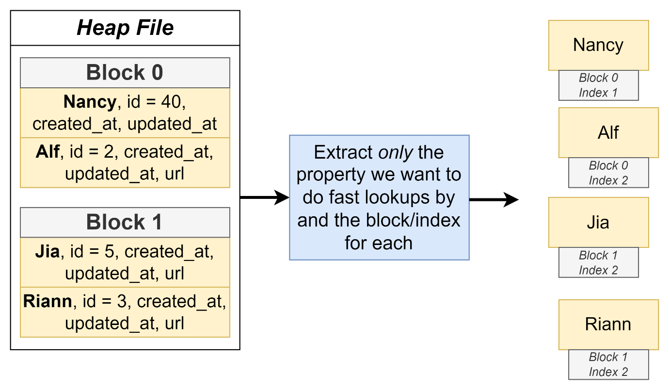

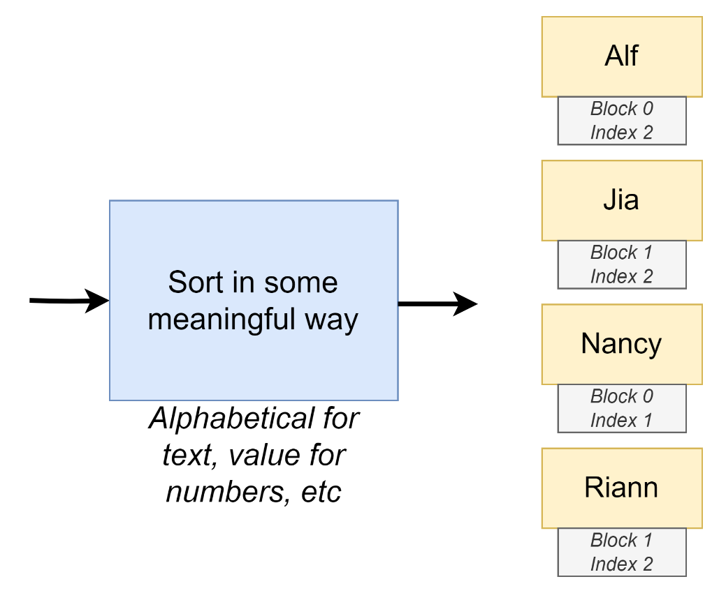

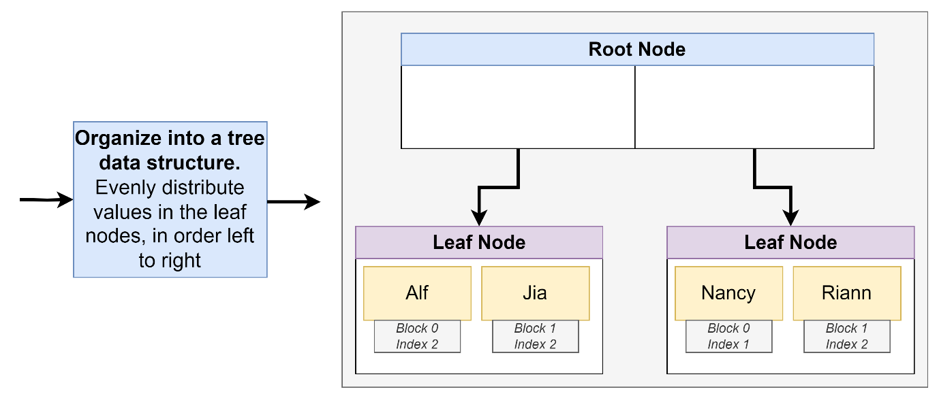

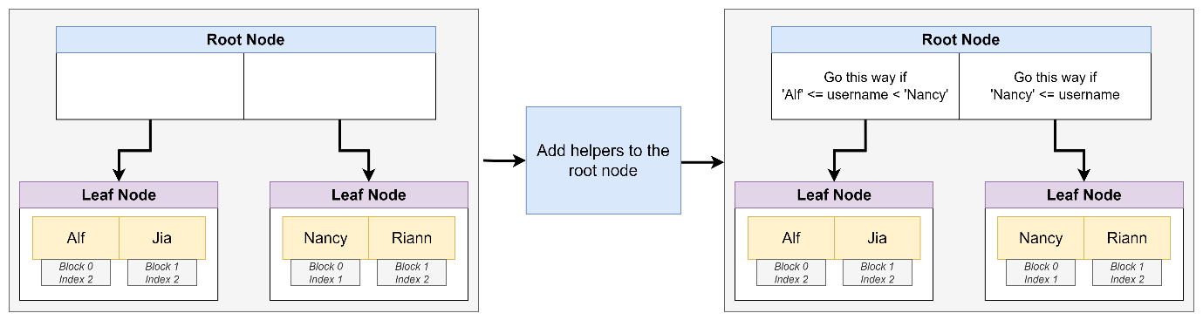

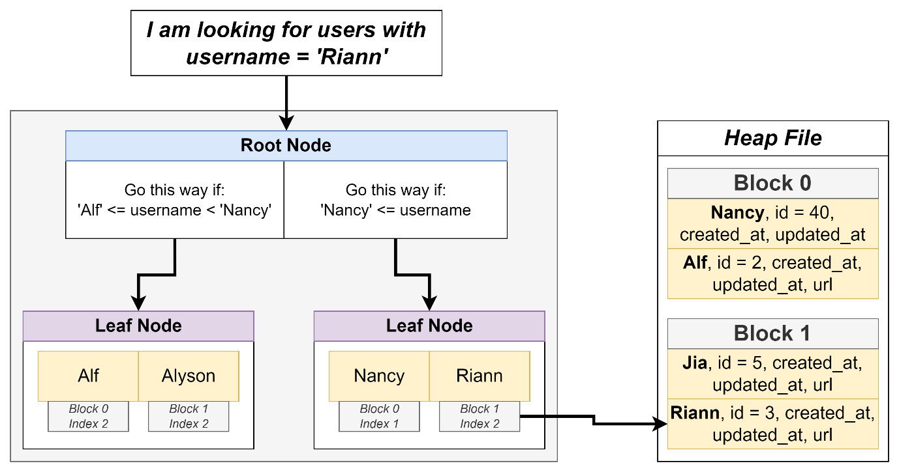

## 193. Creating an Index

CREATE INDEX users_username_idx ON users(username);

## 194. Benchmarking Queries

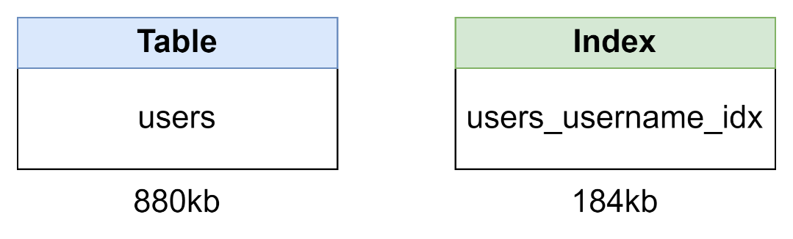

## 195. Downsides of Indexes

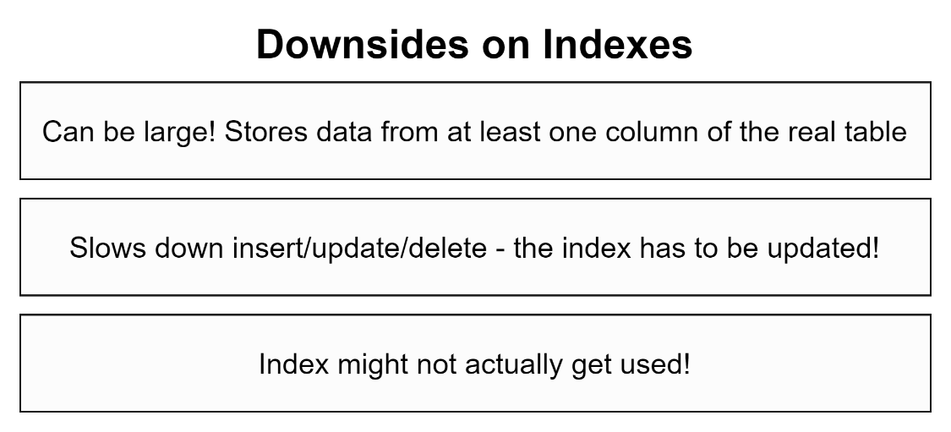

## 196. Index Types

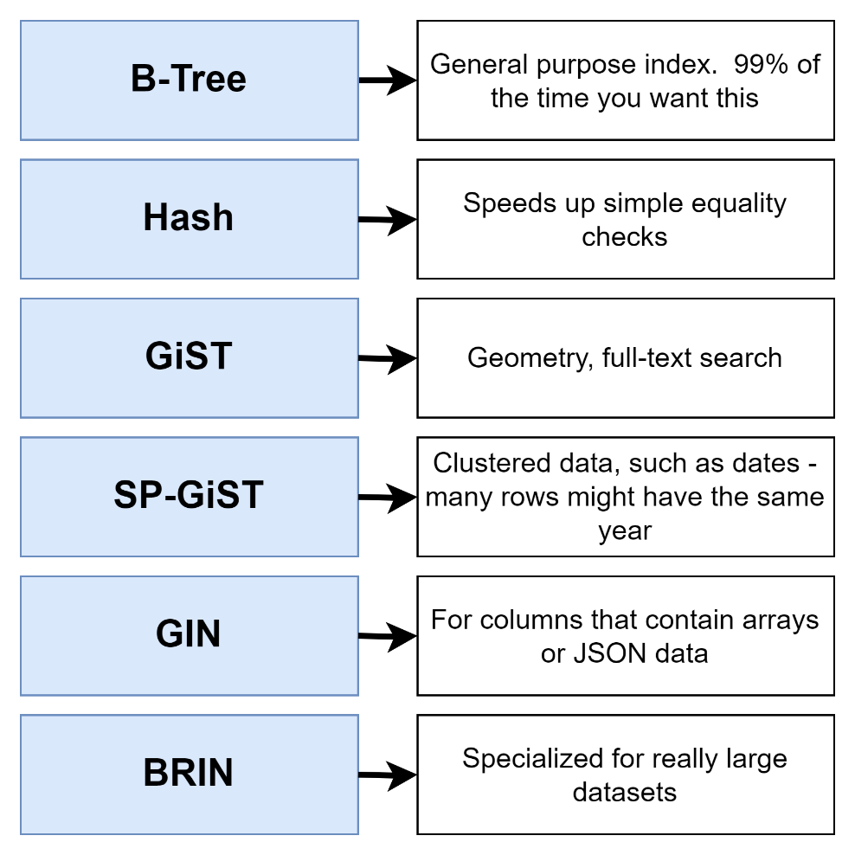

## 197. Automatically Generated Indexes

Select 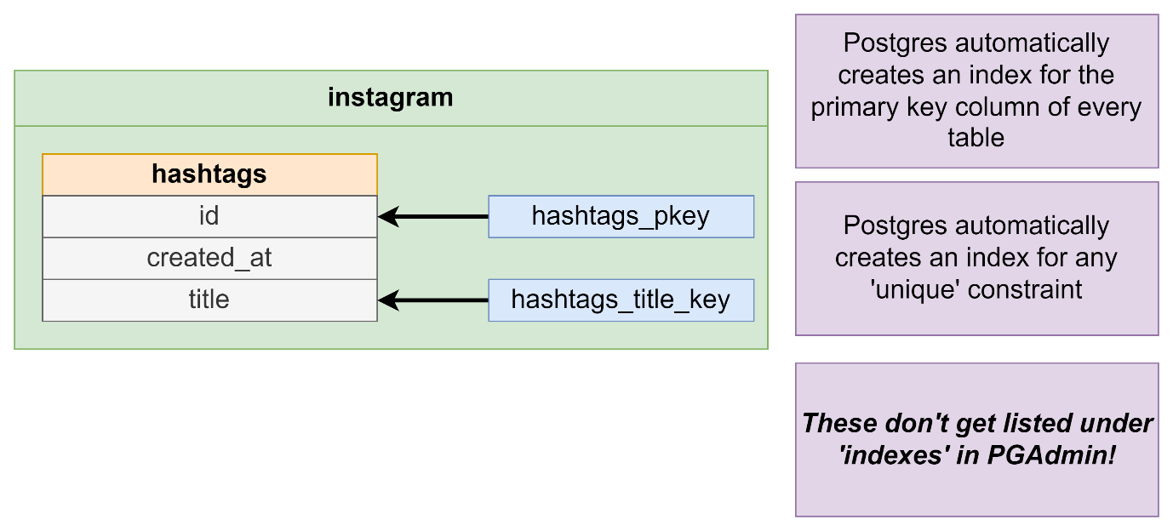

Select pg_size_pretty(pg_relation_size(‘users_username_idx’))

Select relname, relkind

From og_class

Where relkind = ‘i’;

## Quiz 17: Using Automatically Created Indexes

## 198. Behind the Scenes of Indexes

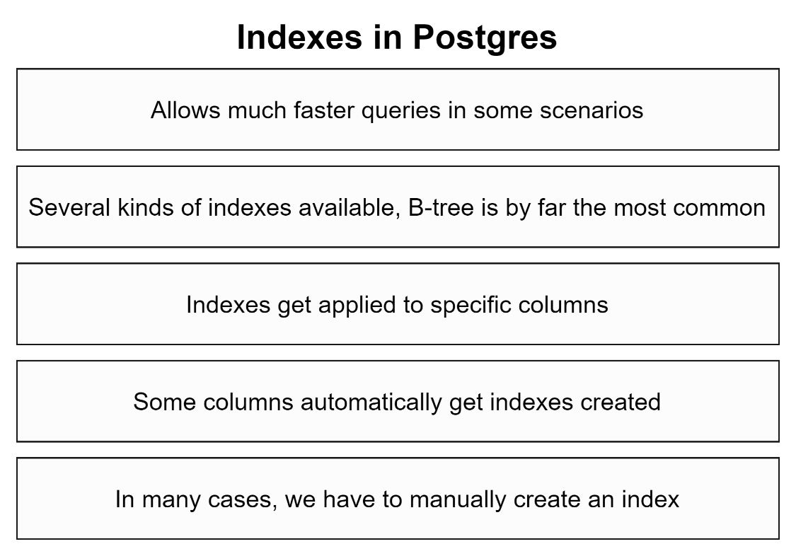

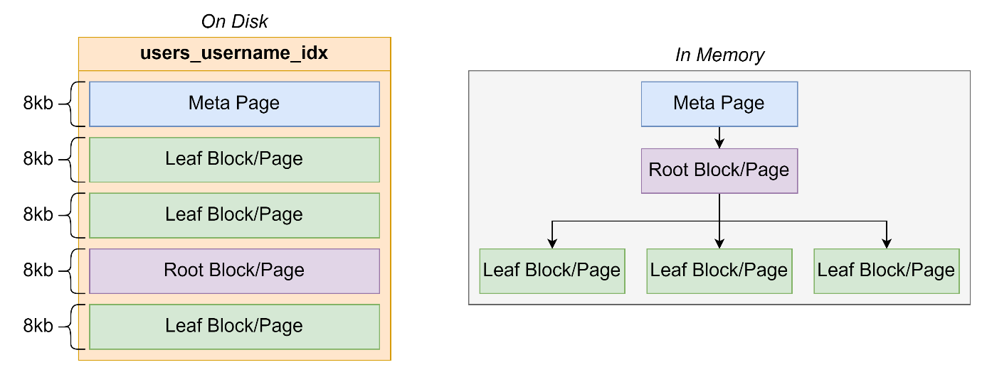

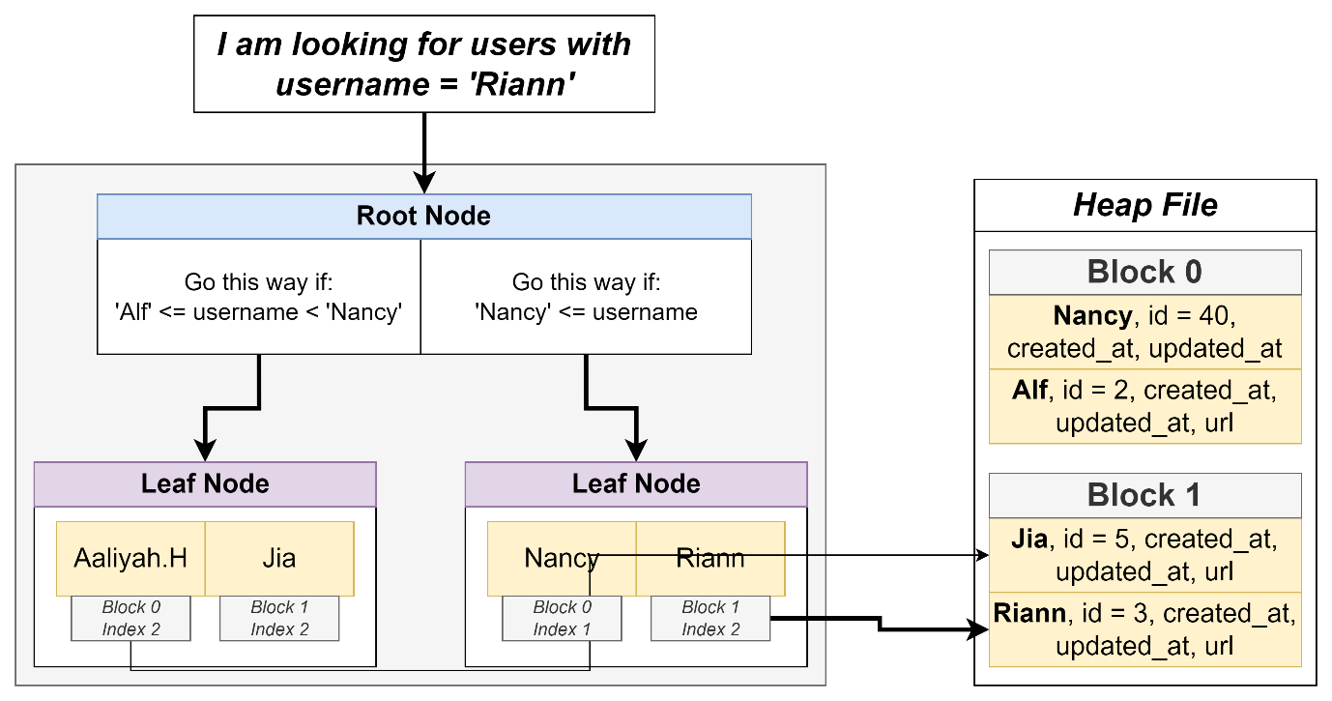

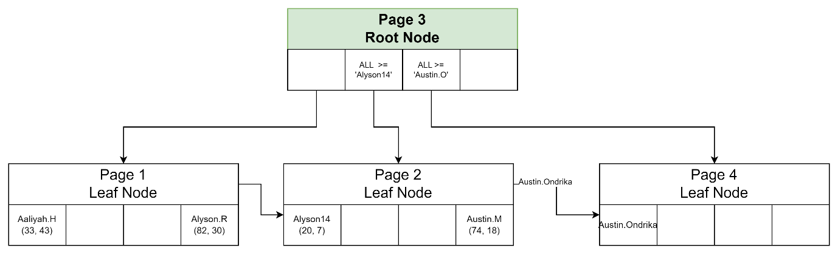

## 

## 199. The Query Processing Pipeline

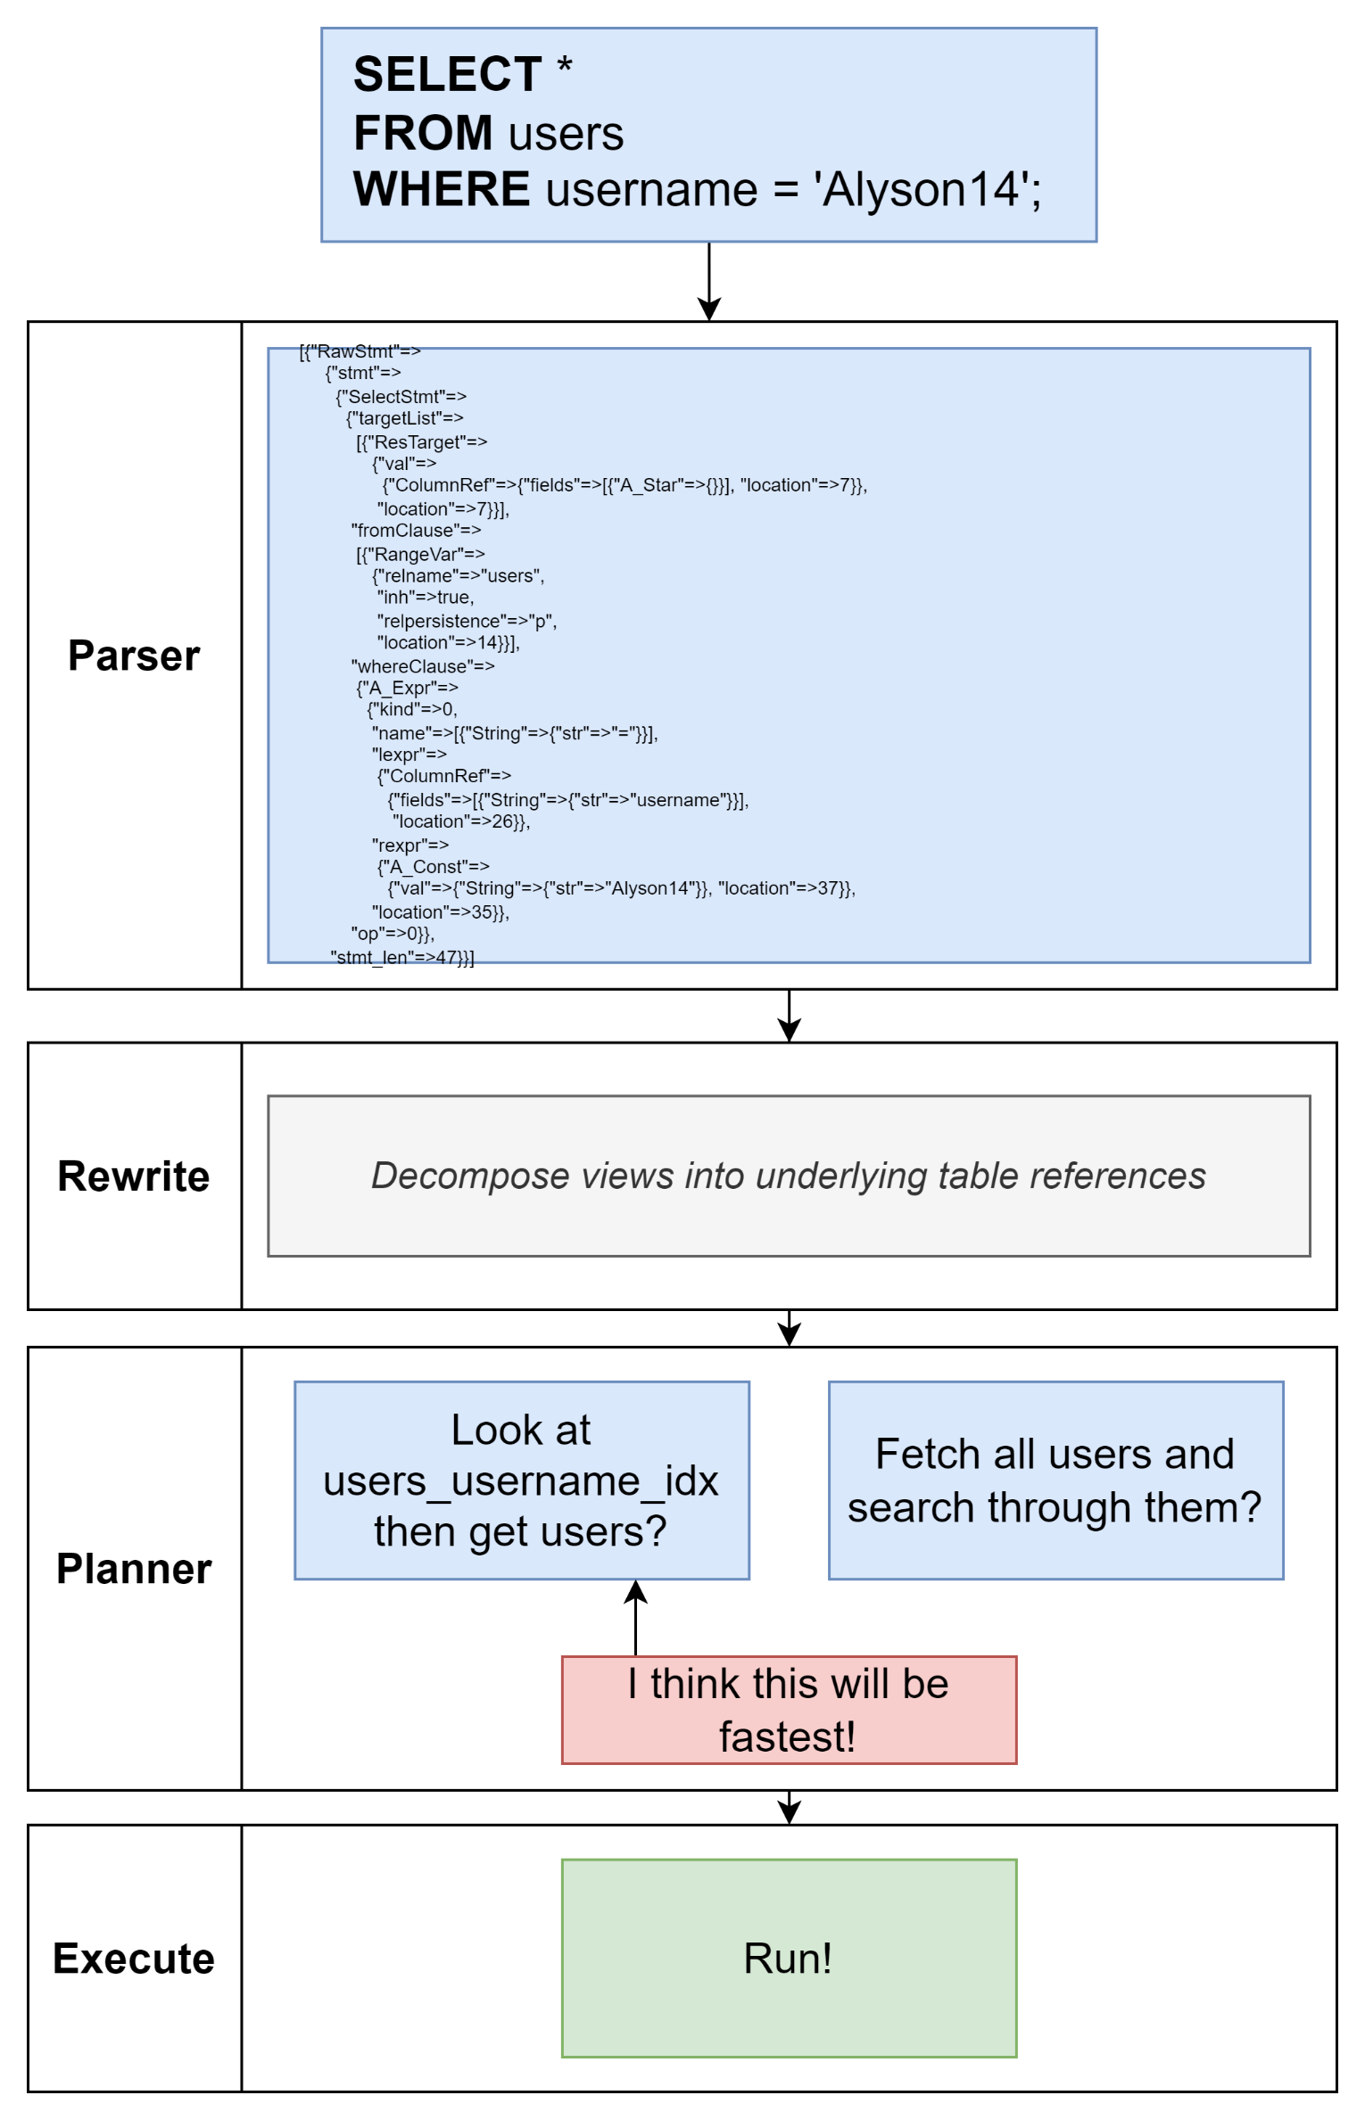

## 200. Explain and Explain Analyze

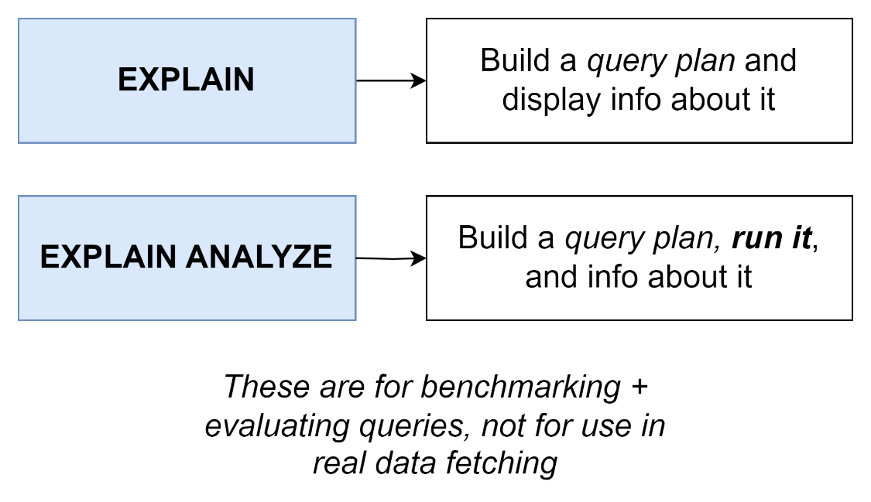

## Quiz 18: Explain Vs Explain Analyze

## 201. Solving an Explain Mystery

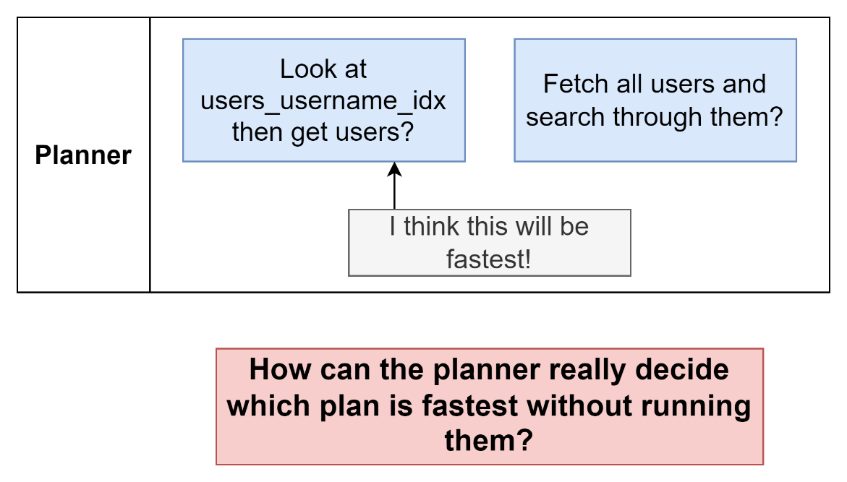

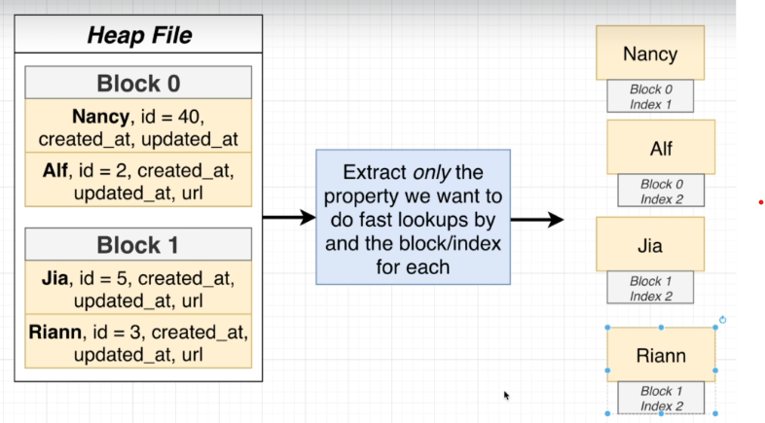

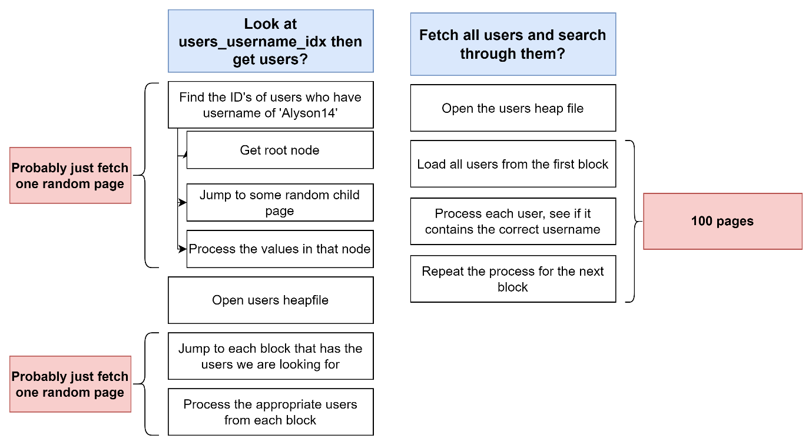

## 202. Developing an Intuitive Understanding of Cost

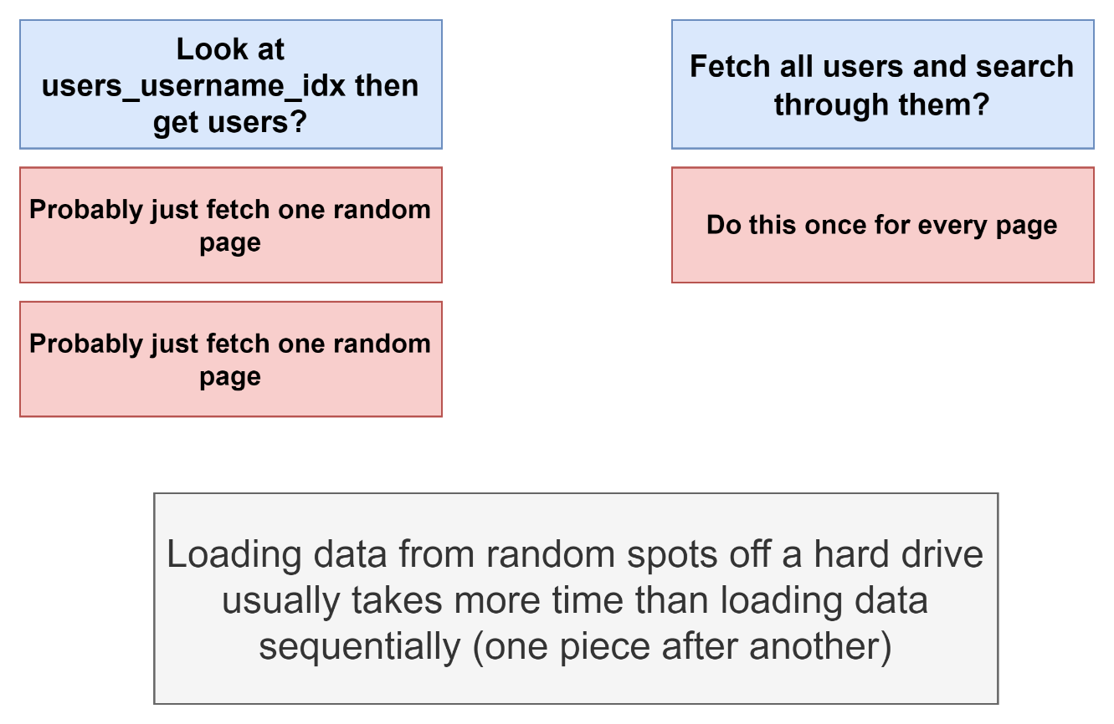

## 203. Calculating Cost by Hand

## 204. A Touch More on Costs

## Quiz 19: Calculating Costs

## 205. up vs Total Costs

## 206. Costs Flow Up

## 207. Use My Index!

## 208. Common Table Expressions

## 209. A Quick Solution

## 210. So What's a CTE?

## 211. Recursive CTE's

## 212. Recursive CTE's Step by Step

## 213. Why Use Recursive CTE's?

## 214. Writing the Query

## 215. Walking Through Recursion

## 216. Most Popular Users

## 217. A Possible Solution for Merging Tables

## 218. Creating a View

## 219. When to Use a View?

## 220. Deleting and Changing Views

## 221. Materialized Views

## 222. Grouping by Week

## 223. Reminder on Left Joins

## 224. Writing a Slow Query

## 225. Creating and Refreshing Materialized Views

## Quiz 20: Views vs Materialized Views

## 226. What are Transactions Used For?

## 227. Some Sample Data

## 228. Opening and Closing Transactions

## 229. Transaction Cleanup on Crash

## 230. Closing Aborted Transactions

## 231. A Story on Migrations

## 232. Migration Files

## 233. Issues Solved by Migrations

## 234. A Few Notes on Migrations Libraries

## 235. A Note About Node Installation

## 236. Project Creation

## 237. Generating and Writing Migrations

## 238. Applying and Reverting Migrations

## 239. Generating and Applying a Second Migration

## 240. Schema vs Data Migrations

## 241. Dangers Around Data Migrations

## 242. Properly Running Data and Schema Migrations

## 243. Creating a Posts Table

## 244. A Small Web Server

## 245. Web Server Setup Instructions

## 246. Adding the Loc Column

## 247. Writing Values to Both Columns

## 248. Transaction Locks

## 249. Updating Values

## 250. Migrations Setup Instructions

## 251. Updating the App Server

## 252. Dropping the Last Columns

## 253. Section Goal

## 254. Initial Setup

## 255. One Fast Migration

## 256. Building the Users Router

## 257. Understanding Connection Pools

## 258. Validating Connection Credentials

## 259. Query and Close

## 260. The Repository Pattern

## 261. Creating a Repository

## 262. Accessing the API

## 263. Casing Issues

## 264. Fixing Casing

## 265. Finding Particular Users

## 266. SQL Injection Exploits

## 267. Handling SQL Injection with Prepared Statements

## 268. Preventing SQL Injection

## 269. Reminder on Post Requests

## 270. Inserting Users

## 271. Handling Updates

## 272. And, Finally, Delete

## 273. A Note on Testing

## 274. Assertions Around User Count

## 275. Connecting to a DB For Tests

## 276. Disconnecting After Tests

## 277. Multi-DB Setup

## 278. Assumptions Around Content

## 279. Issues with Parallel Tests

## 280. Isolation with Schemas

## 281. Creating and Accessing Schemas

## 282. Controlling Schema Access with Search Paths

## 283. Routing Schema Access

## 284. Strategy for Isolation

## 285. Programmatic Schema Creation

## 286. Escaping Identifiers

## 287. Test Helpers

## 288. Cleaning up Schemas and Roles

## 289. Finally... Parallel Tests! (Final Lecture)

## 290. Bonus!